2018

VICELAB

Written by: Jacques Fracchia Reviewed by: Anna Fryjoff-Hung

5/25/2018

Google Earth Engine Guide

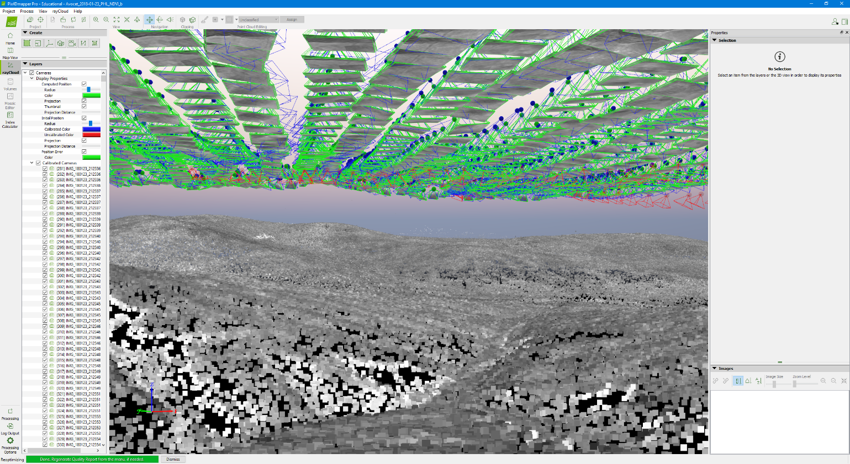

Table of Contents

Foreword 2

Initial Setup 4

Prepare GCPs 4

During flight 6

Post-flight 7

The Basics 8

Pix4D outputs 8

Templates 8

Merging vs. Fusing 8

Best Practices 9

Standard Project (Single Flight) 10

Step 1 – Prepare Folders 10

Step 2 – Starting a Project 11

Step 3 – Remove Takeoff and Landing 15

Step 4 – Calibration 19

Step 5 – Initial Step & rayCloud Editor 24

Step 6 – Marking GCPs 28

Step 7 – Point Cloud & DMS/Ortho Generation 38

Merged Project 40

GoPro Project (Georeferencing Images) 49

Troubleshooting 58

Common errors 59

Solutions 62

* Foreword

This guide was created to teach the reader how to download satellite images from planet labs and to utilize Google Earth Engine’s API to graph NDVI over time for a specific area. This guide does not explain everything Google Earth Engine has to offer, is recommended to read through Google’s tutorials and guide which will teach you the basics on how to code and use Google Earth Engine. If you are not an experienced coder than using Google Earth Engine is perfect for you. It was created in a way where anyone can understand and learn how to use it, if there is something you come across that you do not know, the Google Earth Engine Guide will explain anything you need.

**Some useful resources:**

Google Earth Engine:

<https://code.earthengine.google.com/>

Planet Lab’s Satellites:

<https://www.planet.com/docs/spec-sheets/sat-imagery/>

The following chart describes the process workflow. The process has four main steps, downloading the satellite data, preparing and importing the data into google, writing JavaScript code in GEE, then running the images through GEE to graph the NDVI values over time.

Initial Setup

Sign up for Planet Labs:

**Planet Labs** is an American private Earth imaging company based in San Francisco, CA. The company designs and manufactures Triple-CubeSat miniature satellites called Doves that are then delivered into orbit as secondary payloads on other rocket launch missions. The two satellites we will use are Rapid Eye 5-band Ortho Tiles and Planet Scope 4-Band Basic.

* Go to <https://www.planet.com/explorer/> and sign up for an account.
  + You can use their service for free but they cap your weekly imagery download, you may find having two planet accounts useful in order to download more imagery every week.

Sign up for Google Earth Engine:

**Google Earth Engine** combines a multi-petabyte catalog of satellite imagery and geospatial datasets with planetary-scale analysis capabilities and makes it available for scientists, researchers, and developers to detect changes, map trends, and quantify differences on the Earth's surface.

* If you do not have a gmail account please create one: <https://accounts.google.com/SignUp?hl=en-GB>.
* Request to sign up for Google Earth Engine: <https://earthengine.google.com/new_signup/>
  + Allow a few days for your account to be processed and registered, it will not be right away.

Create a Linux Virtual Box:

Virtual Box allows you to have multiple computer operating systems running on a single computer at the same time. The virtual box is another application on your computer that opens a window of another operating system. This allows you to use and run Linux at the same time as your windows computer.

When placing GCPs on the **field**, make sure they are **secured** and that they won’t be displaced during the flight. You may place weights on the black, but never cover the white. Also place them on flat terrain clear from any possible obstruction such as vegetation. Be mindful if you are placing them on or near **roads** or if there are **animals** nearby that can move them. From experience, **cows** are attracted to bright colors and **will eat** **orange flagging**, so do not place them near GCPs.

GCPs can be set up for each flight or left on the field (semi-)permanently. Our wooden GCPs usually degrade within a year. Plan accordingly and make sure that each GCP location is reasonably **accessible**. The GCP coordinates are acquired using **RTK** so a full day may need to be dedicated for **surveying**. Before each mission, GCPs need to be checked to see if they have moved, are damaged, or dirty (need to be **replaced**). A drone can be used to check their location, so it is useful to have a **GCP check** mission ready. For more information on GCPs see the *RTK guide & GCP guide*.

* For processing in Pix4D, GCP locations need to be in CSV format
* Location of CSV should be in data folder in D drive under the project name
  + Ex: D:\data\cowell_ranch\Cowell_Ranch_gcp
* The RTK exports are in Northing(Y) Easting(X) Ht(Z) format. Headers not required.

|  |  |  |  |  |
| --- | --- | --- | --- | --- |
| Name | Lat(North) | Lon(East) | Ht(G) | Codes |
| LA PALOMA BM | 4144912 | 732376.9 | 136.947 | Base |
| 100 | 4144501 | 731879.7 | 160.61 | GCP |
| 101 | 4144483 | 732449.4 | 132.196 | GCP |
| 102 | 4144272 | 732835.3 | 125.485 | GCP |

* During Flight

During the mission, one person should be dedicated to documenting flight information. A flight log needs to be filled out for each flight containing the following information:

* Date & Time of Launch
* Site information
* Launch Location
* Airframe
* Camera
* Starting Image on SD card
* Time of Landing
* Any relevant information such as:
  + A transect was redone
  + Camera problems during flight
  + Early landing due to battery, etc.

The drone log is located on the Google drive; a copy can be downloaded before the flight or a computer needs to be connected to the server during flight. [https://docs.google.com/spreadsheets/d/18xOs_4jxUTywe_8SpnJChavPdZtlipwXfTAO0m7kWP0/edit#gid=1845350252](https://docs.google.com/spreadsheets/d/18xOs_4jxUTywe_8SpnJChavPdZtlipwXfTAO0m7kWP0/edit%23gid=1845350252)

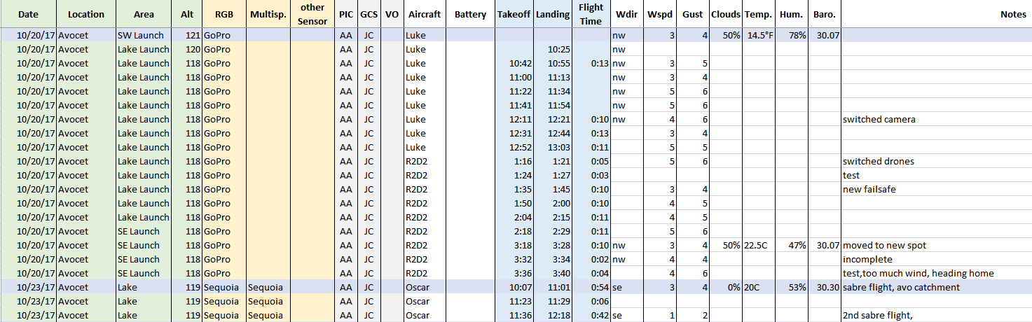

* Post flight – Uploading Data & Processing Log
* Flight images need to be uploaded to the D drive in the appropriate project folder
  + D:\data
  + Folder names should include the project/site + date
  + Sub folders will separate different types of data, i.e. images and videos
  + If multiple flights were acquired, separate them into subfolders with letters (a,b,c,…)
  + Open the ‘read me’ text file for more detail
* You will need an **SD card reader** to upload the data. Plug it into the workstation and open the folder containing the flight data. Make sure to Copy and Paste, not drag (if the transfer get interrupted for some reason, you want to make sure the original data is intact).
* Delete the data from the SD card as soon as it is successfully transferred (otherwise hunting down whether the data was already copied is a pain).

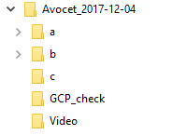

* After the data has been uploaded to the workstation, update the Aerial Data Processing Log. The first page of the log serves as a **status update** to those interested in the **final project**. It should not reflect the raw flight data folder on the workstation.
* For each flight mission, determine how it will be processed. For example, one flight is done and only one map is needed. You will add an entry for that flight, recording the site, date, and area of the mission. You will also input the additional information below, and under ‘Flight’ add the flights included in the project.
  + Example: A mission consists of 3 flights on the same day. The Bands captured are multispectral and RGB using the Sequoia camera. Two maps are desired, one RGB and one NDVI of the entire mission area.
    - The 3 flights should be fused or merged if a map of the entire mission is desired.



* Pix4D Basics

Pix4D Outputs

The Data Processing Log has a list of the outputs that we are interested in.

* Undistorted Images – An undistorted copy of each original image using optimized distortion parameters of the selected camera model. (<https://support.pix4d.com/hc/en-us/articles/202559069>)
* 3D Mesh – 3D representation of shape of the model.
* Point Cloud (LAS) – set of 3D points that reconstruct the model; XYZ and color information stored for each point.
* DSM – (Digital Surface Model) 3D model of mapped area exported as a raster geotiff. Used for raster calculations.

(<https://support.pix4d.com/hc/en-us/articles/206799503-DSM>)

* Orthomosaic – 2D map that corrects the perspective of camera, each point contains X, Y, and color information. Used for visualization.
* Contour (SHP) – Contour lines of terrain exported as a shapefile
* DTM – (Digital Terrain Model) 3D model of mapped area after filtering out objects & plants.
* NDVI – Index map calculated from reflectance
* MSAVI2 – Index map calculated from reflectance

<https://support.pix4d.com/hc/en-us/articles/115002439503-Inputs-and-outputs>

These outputs can be changed based on the templates used.

Processing Options Templates

Depending of the type of project, different templates may be used. However, two templates are primarily used; msavi2_everything, and rgb_everything.

Merging vs. Fusing

In some cases, projects need to be combined in order to generate a single map. This is done by merging or fusing:

* Merging involves processing initial steps of flights separately and adding manual tiepoints to both projects to merge them.
* Fusing simply involves loading in the different flights onto one project and running it. This is done if GCPs in the projects are consistent, meaning most of them are visible in each separate flight. Otherwise they will need to be merged using manual tie points.

Best Practices

**Processing Location** – All active projects will be processed on the C drive. This makes processing go faster (it’s an SSD). There is a decent amount of space on the C drive but make sure to move inactive and completed projects to the D drive.

**Naming scheme**

The names of the projects are important as they tell us information on the date, site, and type of project. The following convention should be followed

Site_YYYY-MM-DD_launch_band

Date, project or site, launch area or flight descriptor, NDVI or RGB

**When to Reoptimize**

Reoptimizing should be done whenever mtps are added, gcps are added, camera parameters are changed, or images are disabled after initial processing is done. Reoptimizing is also important when merging projects (see section on merging).

**Log processes on the data tracking sheet**

Any changes to a project should be logged and new projects that are started should be added.

<https://docs.google.com/spreadsheets/d/1svZJTdIQ-6wC3-jGrD4_A5tPS01PdHltm-c4X1rA2BM/edit#gid=1578735551>

* Standard Projects

Step 1 – Prepare Folders

* Identify which flight needs to be processed. Check the Aerial Data Processing Log to see which datasets need to be processed.

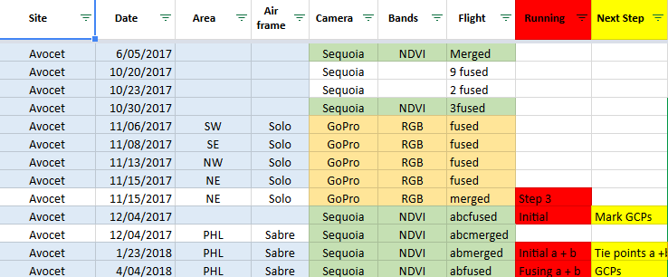

* Create a new **Project Folder**
  + Newest projects will be processed in the **C drive**
    - Location: C:\Pix4D_Processing_Active

Name of folder should be the **project + date**, e.g. **Project_YYYY-MM-DD**

* + **Completed projects will be relocated to the D drive**

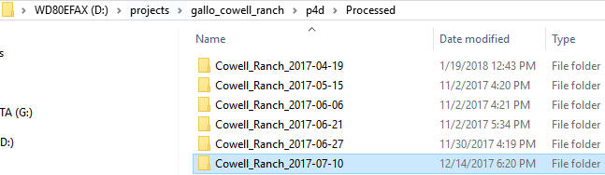

Main Folder; Save Location of pix4D project. Contains individual project folders for dataset.

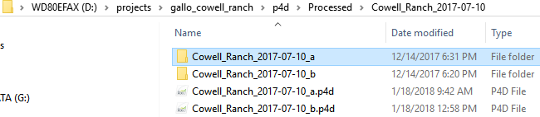

Project Folder and .p4d file; Automatically created inside main folder when saving a new pix4D project. When creating new projects take care to never save inside one of the project folders.

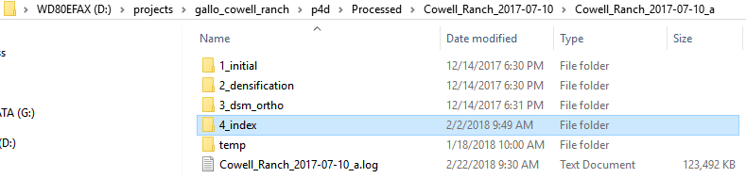

Outputs; Inside the project folders are the program outputs. These are automatically generated inside the project folders.

Step 2 – Starting a Pix4D project

* Open up Pix4D Mapper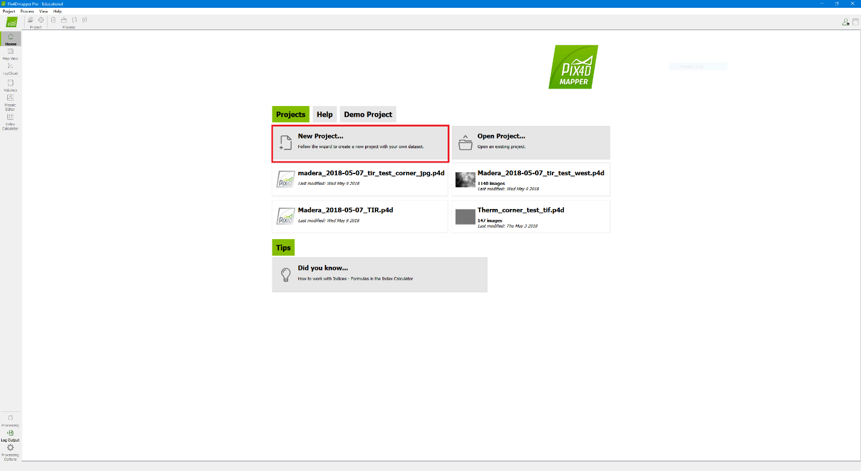
* Click Create New Project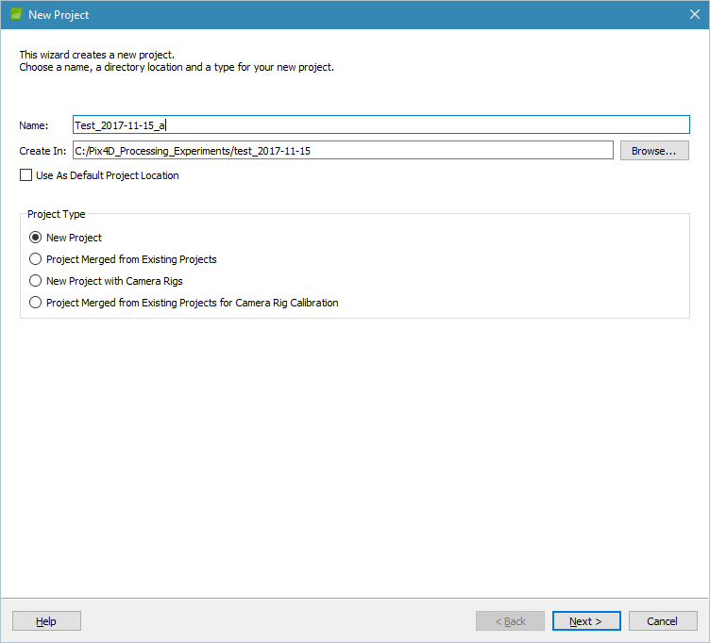
  + **Name the project**, this will be the name of the **.p4d** file as well as the output folder, so make sure to include additional **descriptors** (Site+Date+Area+Band)
  + Create In - asks for the folder the .p4d file will be located, this is the main project folder created in **Step 1**.
  + Project Type – will be New Project, unless you are merging different projects together (see merged project). Hit **Next**
* Loading Images
  + Click **‘Add Images…’** and navigate to the folder with the desired images. This will require you to select all the images that need to be processed, you can hit ctrl+a to select all images in the folder
  + Alternatively, you can add a directory to select all the images in the folder **‘Add Directories…’**. If there are RGB images in the folder, they will be automatically removed upon hitting next. If you want to process only RGB you have to use ‘Add Images’. When looking for a set of images, such as only RGB you can sort the folder by **type**.
  + You can add different flights in the same project using ‘Add Images’ or ‘Add Directories’, we call this **‘fusing’**.

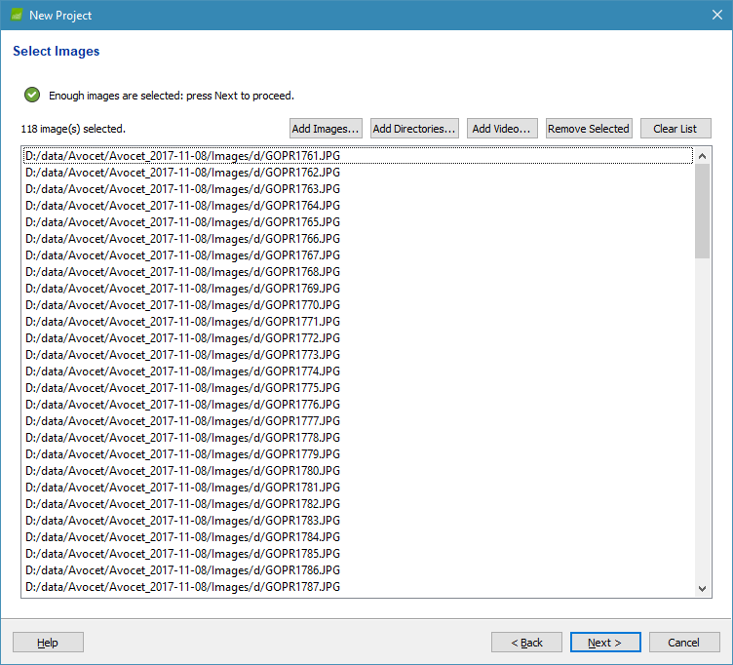

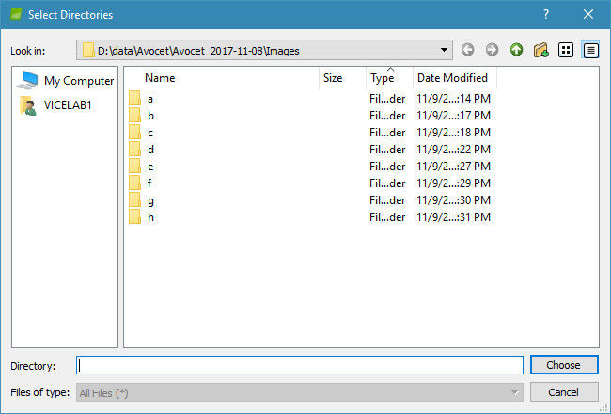

* + After hitting **next** ensure that the project is in the correct **coordinate system** and has **geolocation**. The correct camera model should also be displayed. This will automatically generate for supported cameras, such as the Sequoia. If there is no georeferencing, then this must be added (see georeferencing).
  + 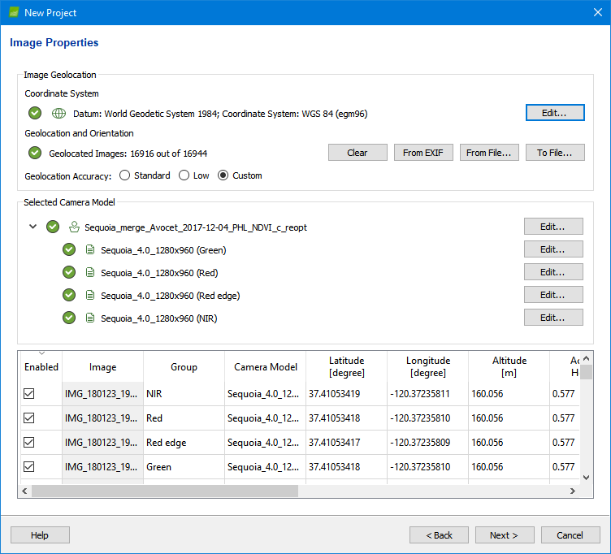Hit **next** until you get to the template section (Settings should automatically generate, and defaults should be kept the same).
* Loading Template
  + **Template – msavi2_everything** is the default template for NDVI projects, **RGB_everything** is the default template for RGB projects
    - You can change the output options afterwards if additional outputs or settings are needed
  + 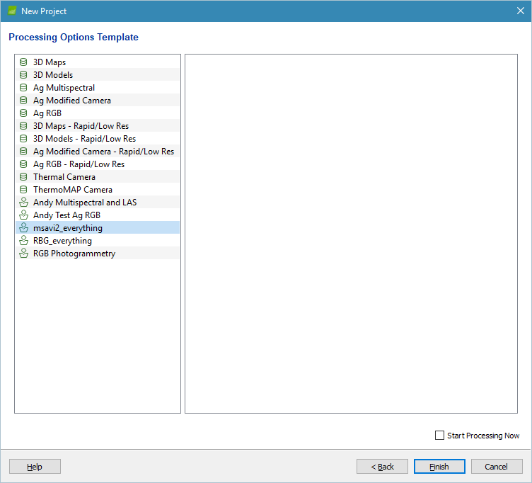One you click F**inish**; the program should load the images. Wait a few minutes while the program loads all the images. This will automatically load the **‘Map View’**

Step 3 – Removing Take-off/Landing

* For Sabre flights, the take-off and landing will need to be removed.
  + On the top left corner of the program, click the **image properties editor.** You may also open the image properties editor using the **Project tab**.

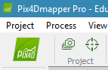

* + In the **image properties editor**, you will need to disable the take-off and landing images of the flight(s).
    - Identifying takeoff/landing can be done visually using the map view. Images going diagonally across the area means takeoff/landing (See page 18).
    - You can click images (**red dots**) to identify which image number it is. Hovering over the images will also display the image number on the bottom of the screen.

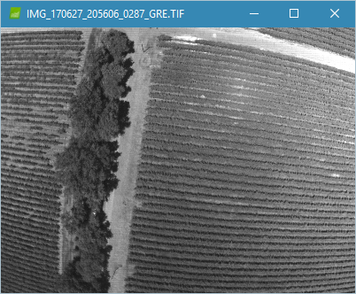

* + - **Takeoff** - The point before the plane starts its first transect is the takeoff, so the **very first image until the beginning of the first transect** will be disabled. (See page 18)
    - **Landing** - The landing is a little more difficult to spot, it may not go diagonally across the screen. Zoom in at the launch spot where there are circles of images and see where images begin to **diverge**, follow the images to the beginning of the transect. The point where the **landing transect** began is the beginning of the landing. Select this image until the last image and disable them.
    - To disable images, select the image, hold shift and press the down arrow (or **pg down**) until you’ve selected all the images. You can also click an image and hold shift, and then click another to select everything in between. Right click under the column **‘Enabled’**, and select **disable selected images**.
      * Tip: To make it easier, write down the identified takeoff and landing images, you can’t click images while the properties editor is open. You can check the image folder to confirm take-off and landing images.

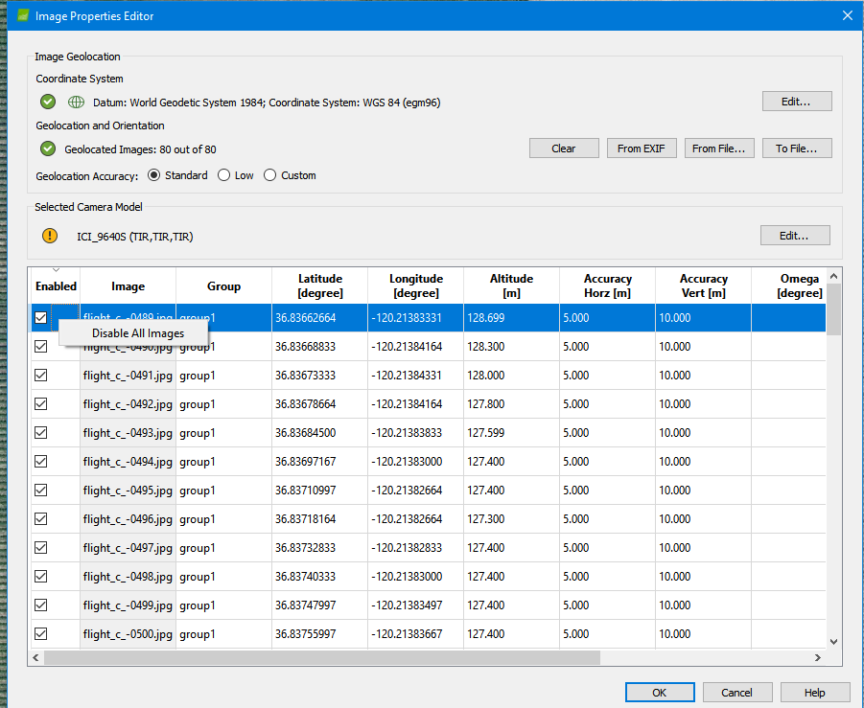

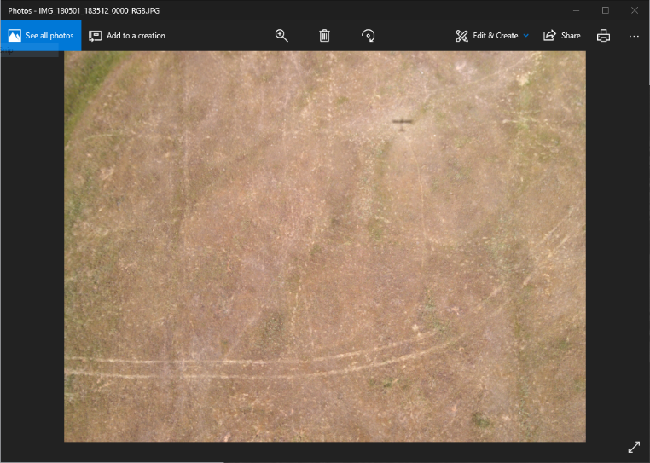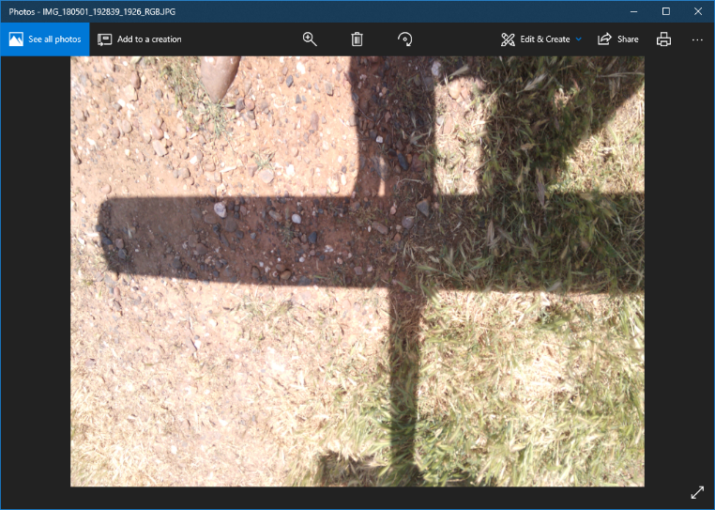

* For fused projects, there will be multiple take-off and landings. It may help to look in the data folder and check which images are the take-off and landings for each flight. Write down the image number and search for it in the map view.

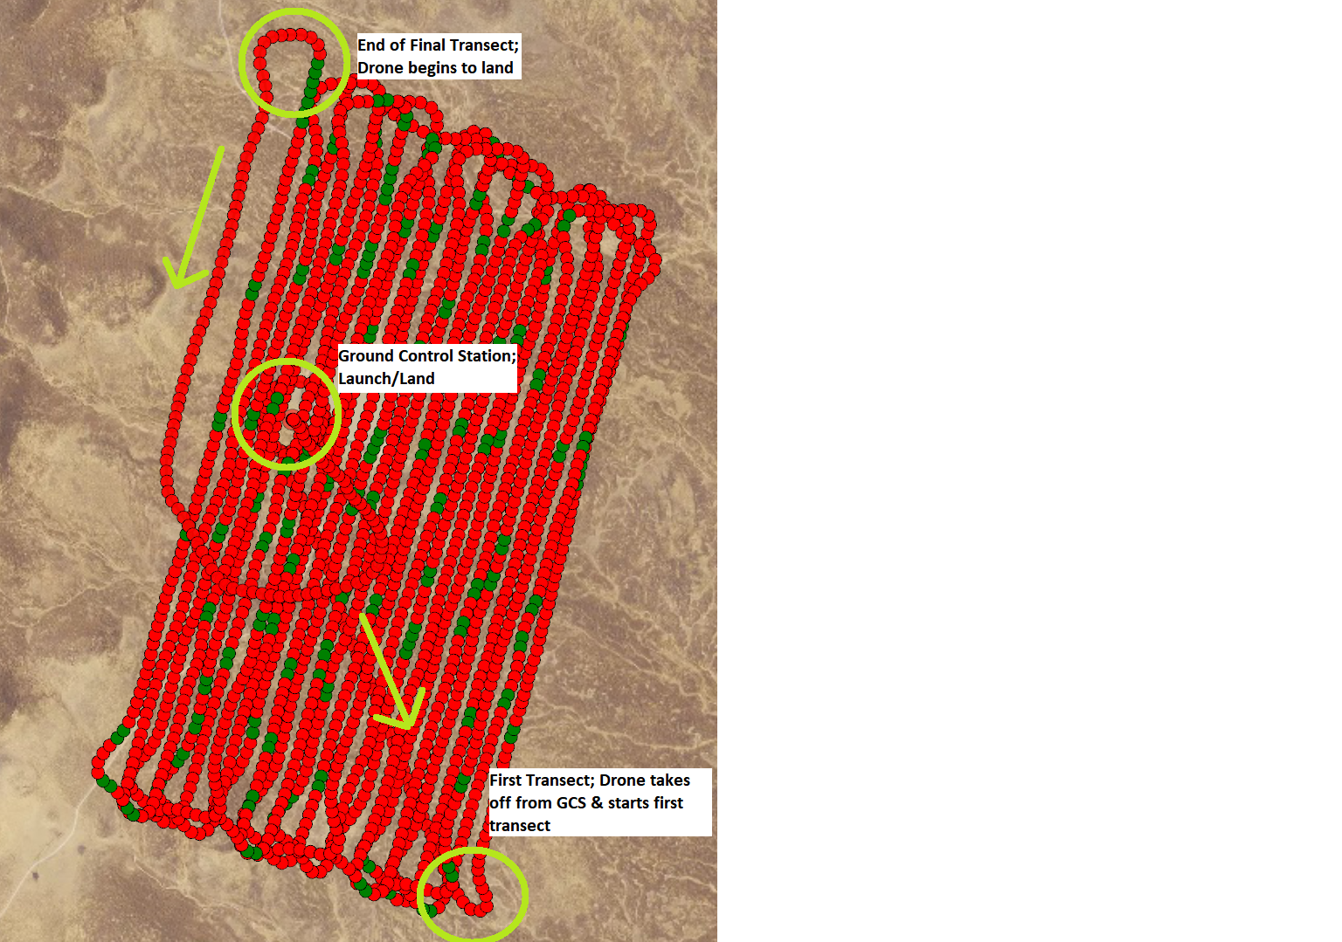

Step 4 – Calibration

<https://support.pix4d.com/hc/en-us/articles/206494883-Radiometric-calibration-target#label1>

* For multispectral projects, the images need to be calibrated.
* Under **Processing Options** select **3. DSM, Orthomosaic and Index** and Click **Index Calculator.**
* You will see each camera listed,
* Choose a Camera and click **Calibrate…**

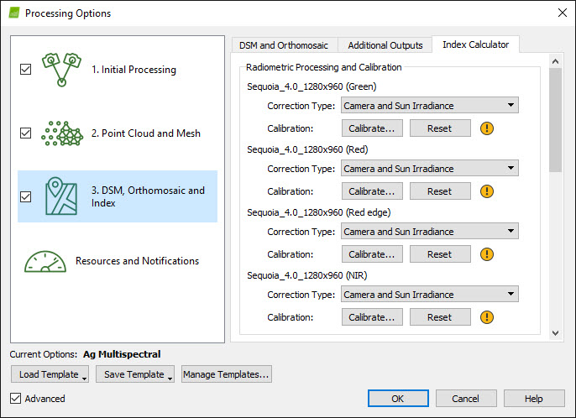

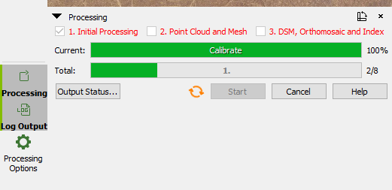

* Click **Browse...** and navigate to the calibration pictures. These are located in the data folder with the images.
* There will be three sets of calibration images, with different exposures. Choose the set that is not over-exposed (white), or under-exposed (too dark).
* The calibration picture will vary depending on the camera you are correcting. The program will give an error message if you chose the incorrect image.

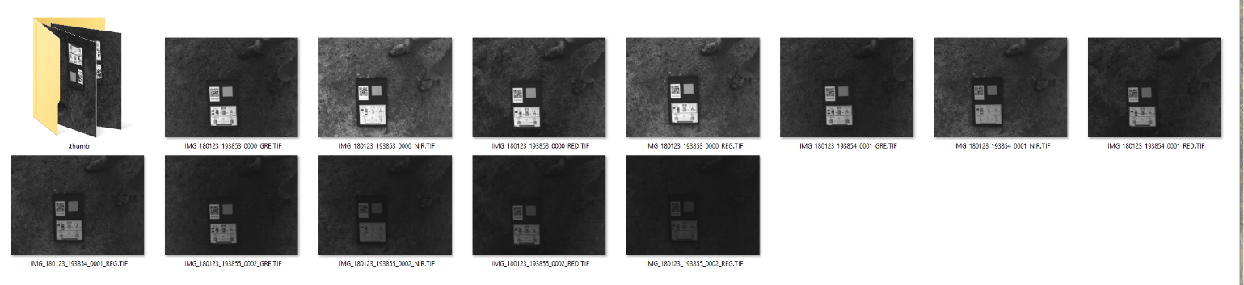

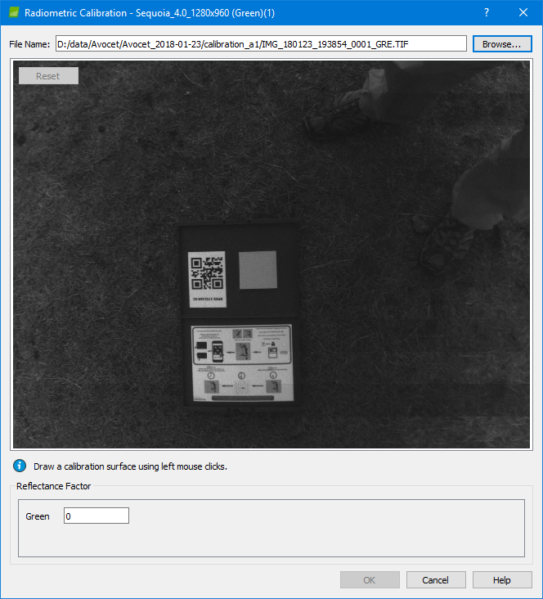

* **Zoom in** to the image and **draw a box** around the **calibration panel**. Left click will add points, and right click will finish the polygon. If there are intersecting lines, you cannot proceed. You can reset the drawing by clicking the Reset button on the top left.
* **Identify** which calibration panel was used. The barcode is located next to the target. We use two different panels, both of which are listed on the next page.
* Input the **Reflectance Factor**, the **values** are listed on the next page. Make sure you are using the correct camera and band values. Hit **OK** and repeat the steps for the rest of the cameras.

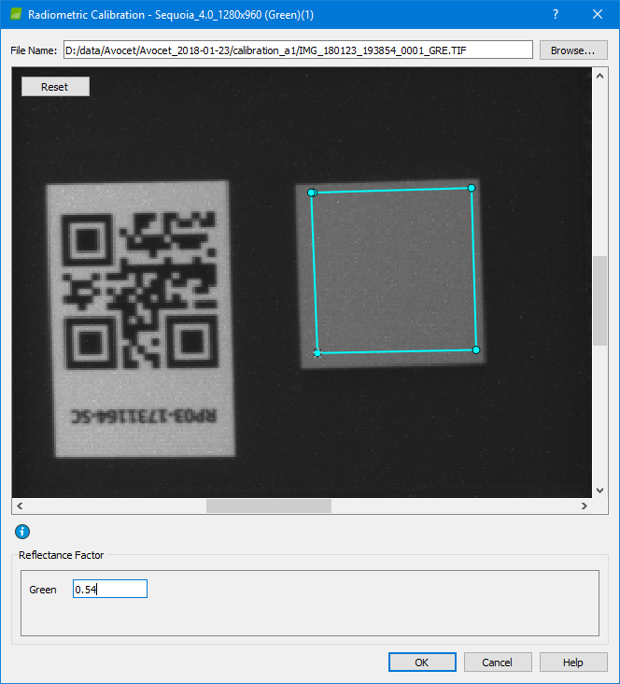

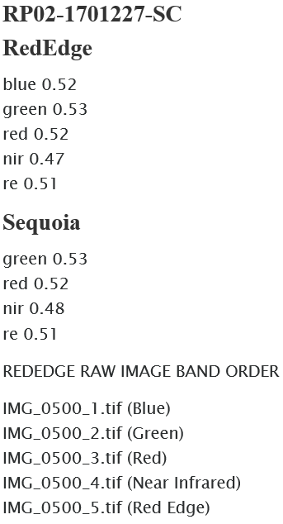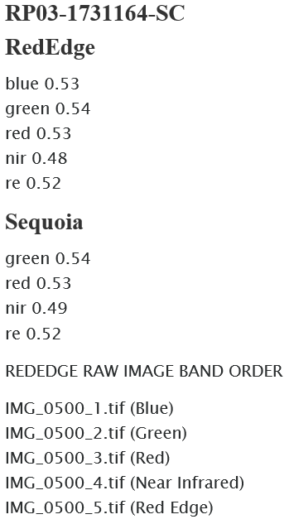

* Once Finished, ensure that all cameras have a **green check mark**, which indicates that correct targets were used.
* Hit OK.
* Calibration needs to be done for each project. In case you are adding multiple flights in a project, use calibration images that were taken in between the two flights.

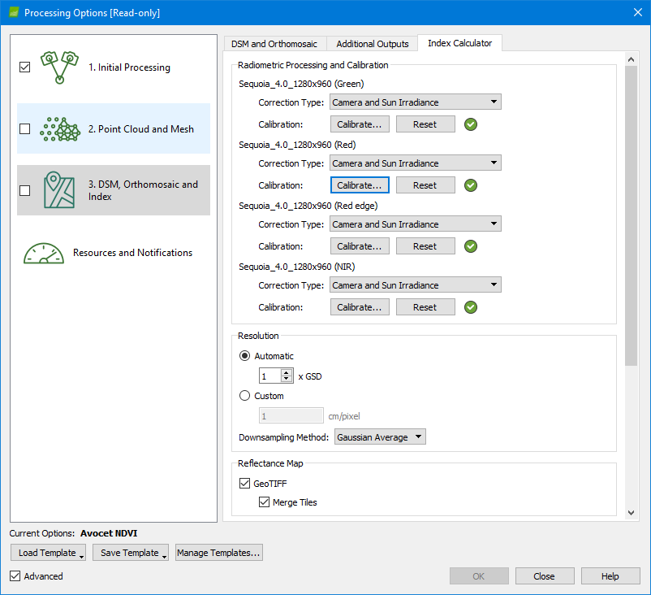

Step 5 – Initial Step

* Once take-off and landing have been removed, you can begin initial step.
* Check to see if you are using the correct template
  + **MSAVI_everything** is the most common for NDVI flights
  + **RGB_everything** is used for RGB flights
* Check the initial processing box and click **Start**. **Do not** check the other two boxes.

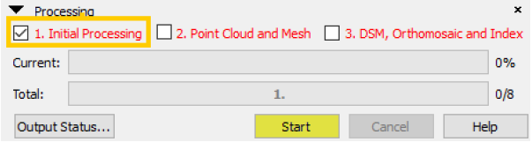

* Depending on the size of the project, step 1 may take from several hours to a few days.

**Checking the sparse point cloud** using the **rayCloud Editor**

* **Automatic Tie Points** (ATPs) are 3D points calculated from matched images. They appear as white dots on the rayCloud editor and contain X, Y, Z information. They are the basis for future steps so it is important to check for any errors.
* You can navigate the rayCloud using the mouse. **Left click** and drag to move the map around. **Right click** or use the **scroll wheel** to adjust the zoom level. Hold the **mouse wheel button** (M3) to adjust the camera, or hold **Shift + left click**. Alternatively, you can use the **navigation pane** on the top of the page. You can also use the **focus on selection** button if the camera gets lost.

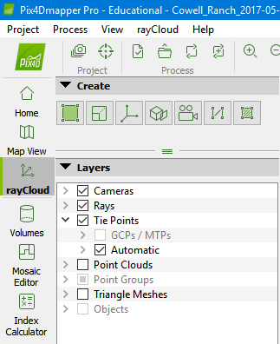



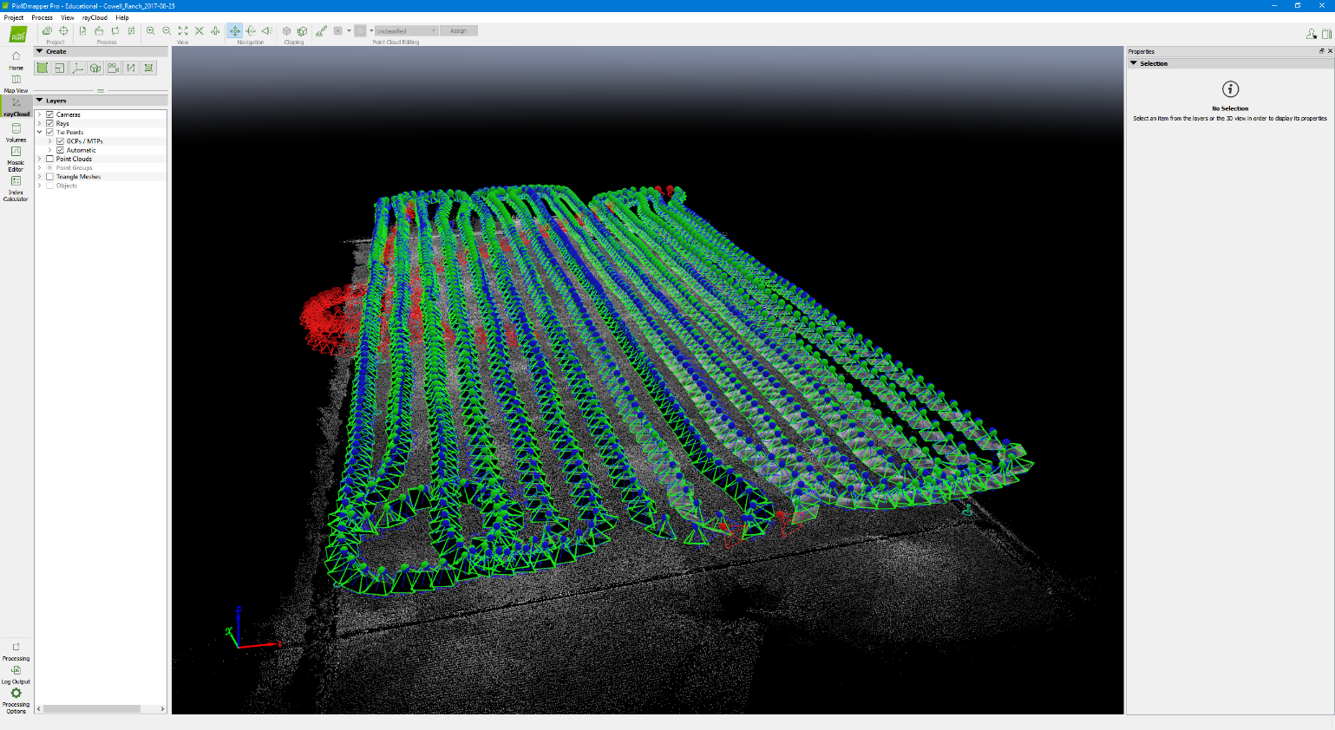

* The display properties are explained on the sidebar. One thing to check is that the **correct images are disabled**. As shown above, the images disabled are take-off and landing (red polygons)

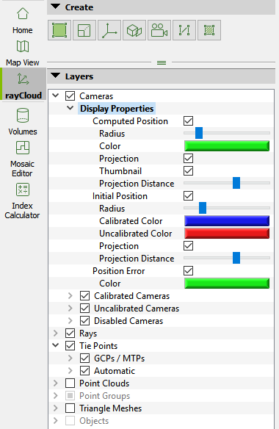

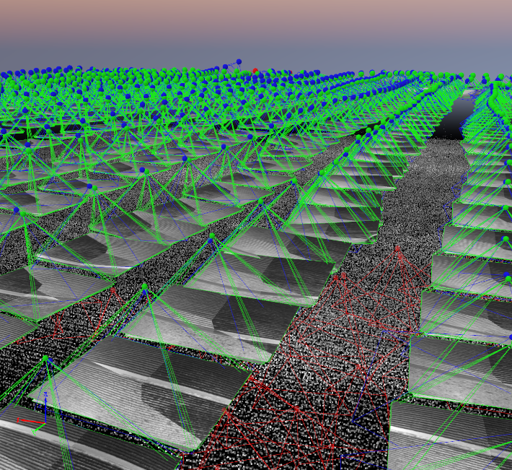

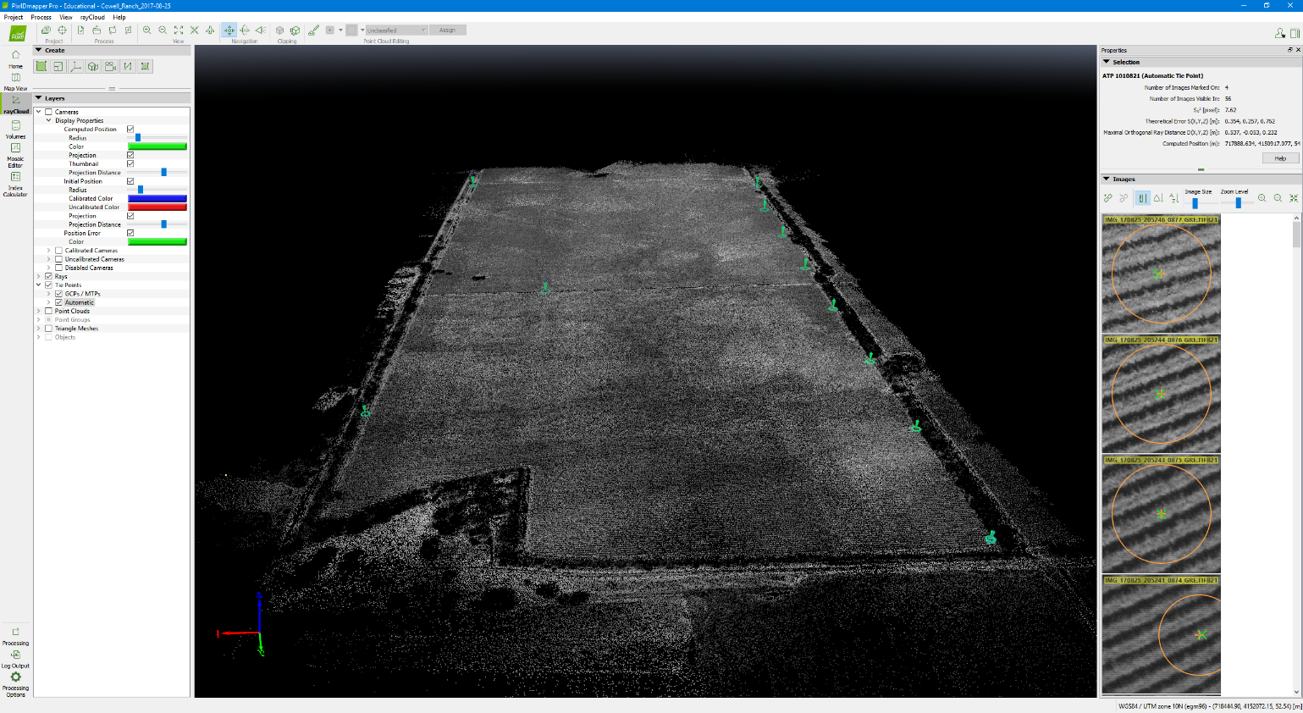  
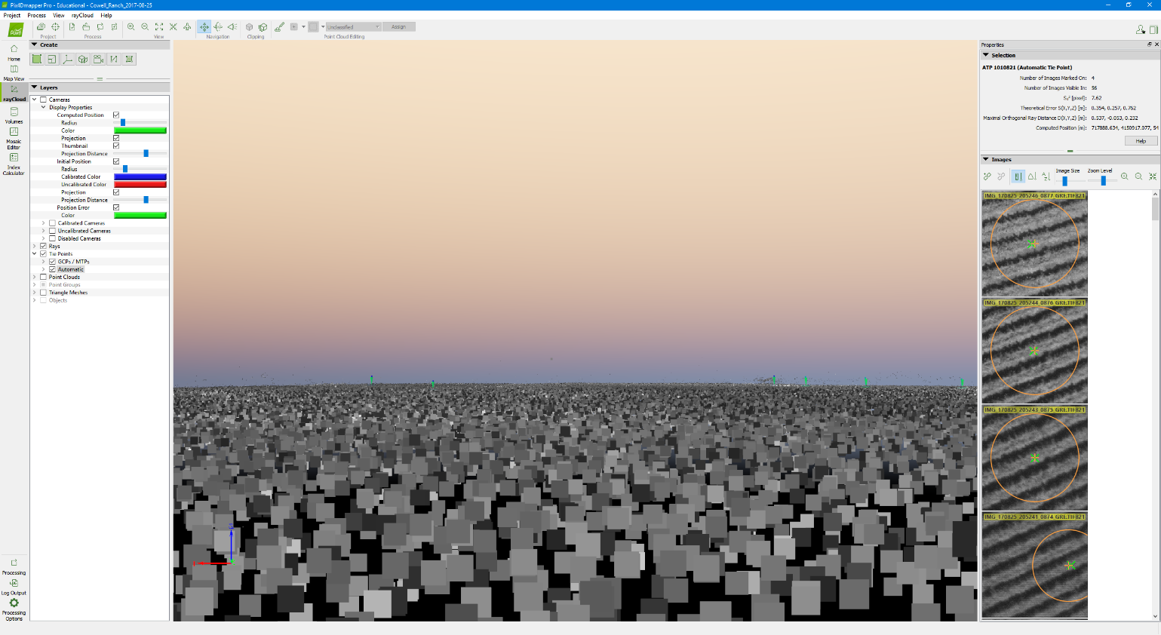

* You can disable the displayed cameras by unchecking the boxes on the sidebar.
* Check the **ATP cloud** (shown above) for several artifacts such as (see troubleshooting section)
  + **Layering** – there are tie points on top of each other, creating more than one layer of points. This artifact is most common in merged projects.
  + **Holes** –there are gaps in the automatic tie point cloud that was fully covered by the flight.
* If artifacts are found. Try
  + **Reoptimizing** the project (see Step 5)
  + **Adding manual tie points** (see merged project)
  + **Disabling cameras** (see troubleshooting)

Step 6 – GCPs (manual)

* Pinpointing GCPs will take at least an hour. The program is prone to crashing, so **make sure you are saving after each GCP marked** (Shortcut ctrl+s).
* First open up the **GCP/MTP Manager**



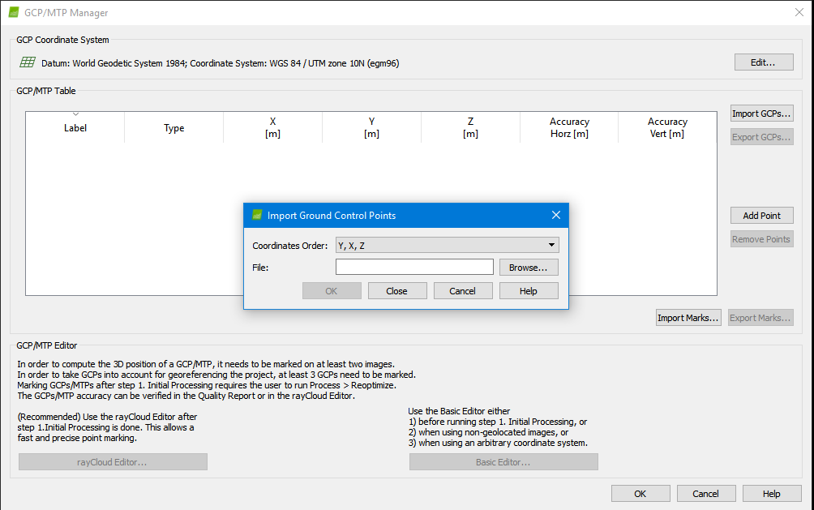

* Load the GCP file (.csv), this should be in the same folder the images are at. Click browse, navigate to the folder with the **GCP file**, open the file. Order will be (**Y, X, Z**) corresponding with Northing, Easting, Elevation
  + Click OK, the points will display on the left side of the ray editor.
  + They are represented as cones with circles on the ATP cloud and blue crosses on the map view.
  + You may turn off the cameras to see the GCPs better

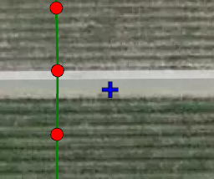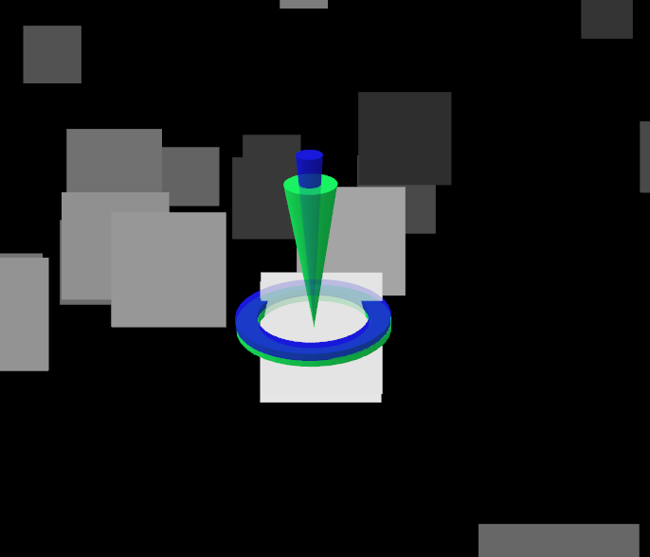

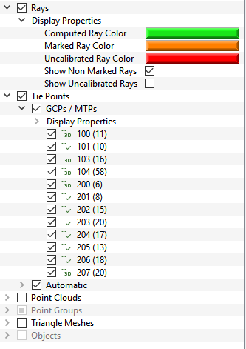

* Pinpoint GCPs
  + Click on a **GCP**, on the ATP cloud or the **left side bar**, under **Tie Points**. You can quickly focus on it using the **‘focus on selection’** button.
  + Once a **GCP is selected**, matched images will appear on the right side of the page. The properties will also appear on the right side. Ensure that the tie point selected is a **3D GCP**. You can adjust the **sizes** of the display and the zoom level of each image. You can also drag the sidebar to the left to increase the number of images displayed. This will make marking GCPs easier.

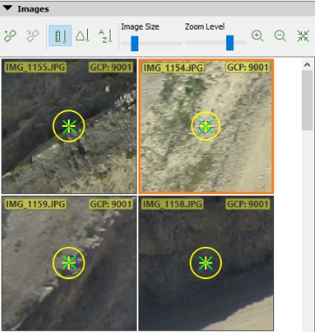

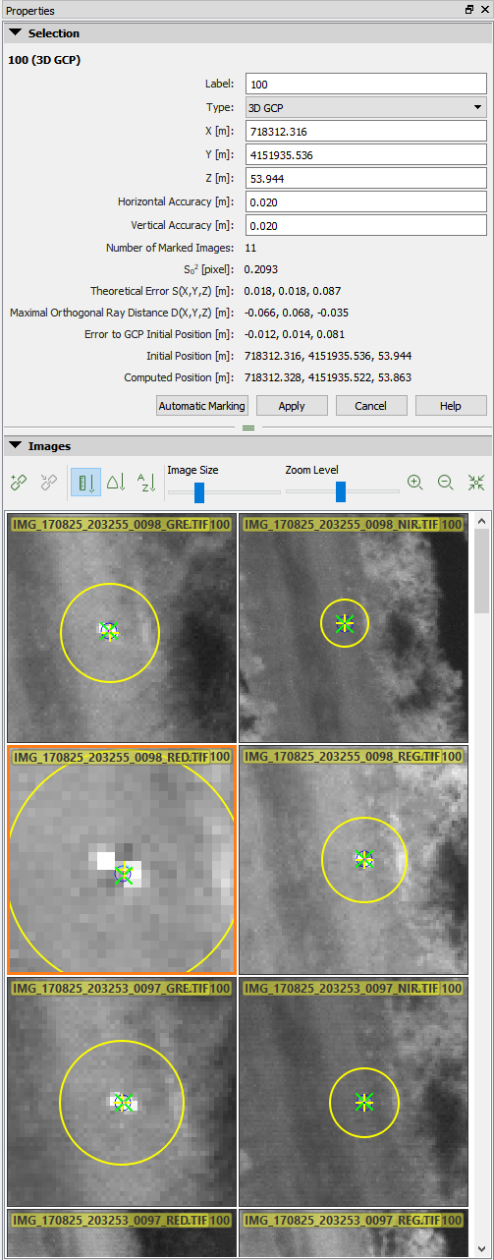

* You will click the actual GCP location on the image, if the GCP is the checkerboard pattern, click on the **center** where the white and black corners converge
  + The display should automatically be centered near the GCP, but you can **click and drag** to move the image around and focus on the GCP. You can also zoom in and out using the scroll wheel
  + Clicking anywhere on the image will tell the program where the **actual location** of the gcp is, a bigger **yellow circle** will appear where you clicked.
  + If you make a mistake, hover over the image and hit the **delete** key. Hitting the **cancel** button will remove all the changes you have made to the GCP so be careful.
  + Marking a few GCPs makes a **green cross** appear. This is the computed position of the GCP based on what has been marked. After marking several, you can hit **apply** to bring the initial position closer to the gcp. This will make it easier to mark as the view now displays closer to the gcp. Otherwise you will have to keep dragging the images to the gcp.
  + **Zooming** in and out will decide how much **weight** the program puts on each click, if you are uncertain of the **exact center** of the gcp, zoom out further.
  + Ideally you want to mark at least **12-30** images manually or until it becomes hard to distinguish where the gcp is.
* After a dozen or so **manual marks**, you can click **‘Automatic Marking’** this will automatically mark the remaining images based on optical properties of the manual marks you have made. The more manual marks you made, the more accurate the automatic marking is. Look over all the markings to make sure they are accurate. If they are off, you can click the correct location. Using the image size and zoom level sliders can make this easier. As a test, **zoom in** to the images using the slider and make sure the center of the GCP is clicked. When a reasonable amount of images has been marked hit **Apply** one more time to save the changes. Don’t forget to **save the project** (ctrl + s)

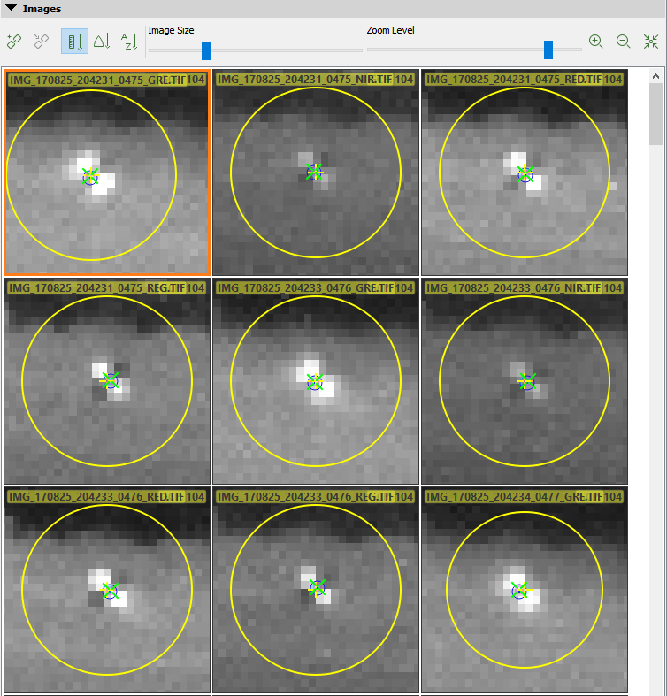

* Check to see if you have marked enough images. Clicking the GCP and turning on **Rays** on the display properties should indicate how many cameras have manual marks. This is indicated by **Orange** rays. Ensure that the GCP has marked cameras on **all sides** or as much as possible.

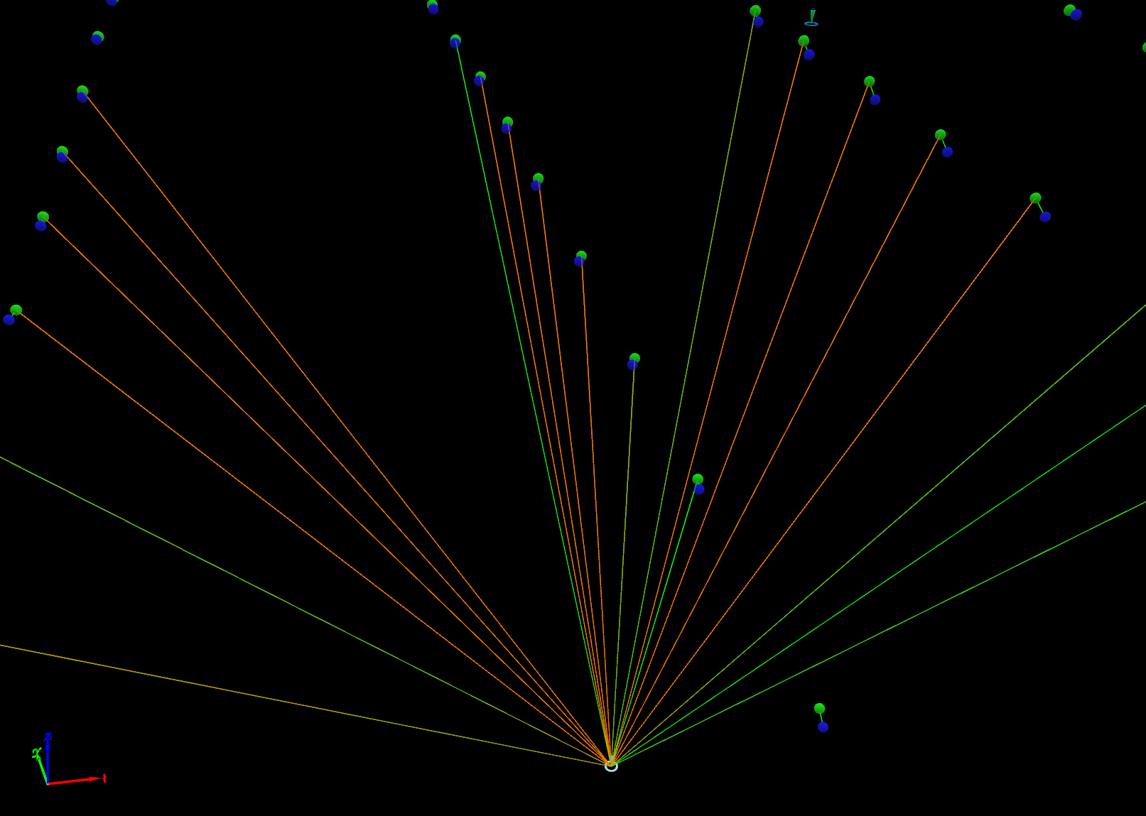

* Checkpoints
  + If there are enough GCPs laid out to have checkpoints, you can treat a few gcps as checkpoints.
  + Checkpoints allow us to determine the accuracy of the georeferencing
  + You can change the property of a GCP by changing its type under the **properties section** tab on the right side.
  + Click the drop down arrow under Type: **3D GCP** and change it to a 3D **Checkpoint**.
  + **Hit Apply** and **Save** any changes made

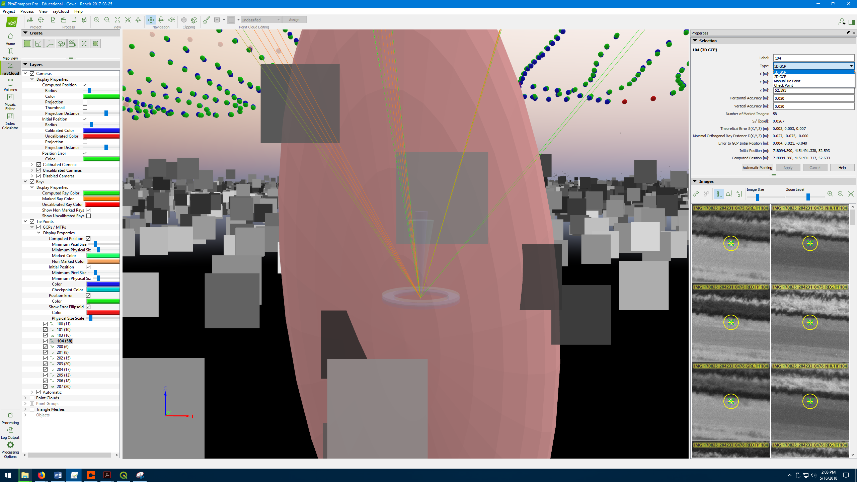

* **Reoptimize** – on the **Process menu**, click **Reoptimize**. This should be done **every time** GCPs and tie points are added.
  + This step takes from a few minutes to hours, depending on the dataset. Steps 2 and 3 may be completed afterwards.
  + If after reoptimization there are still artifacts or large errors in the ATP cloud, consider marking GCPs in more images, or adding manual tie points (see merged project).

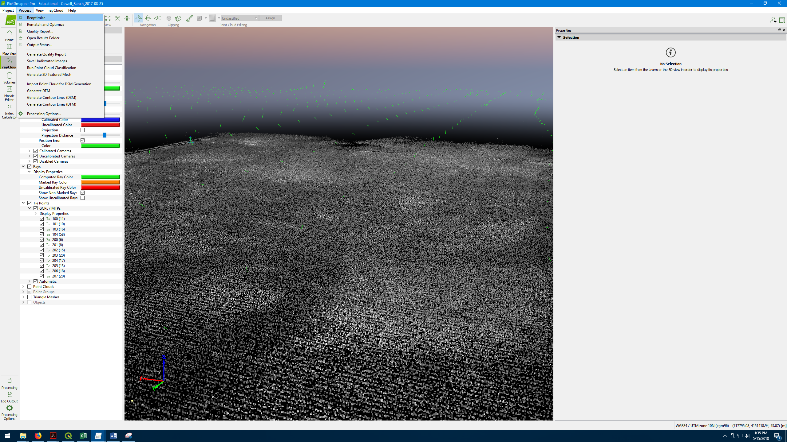

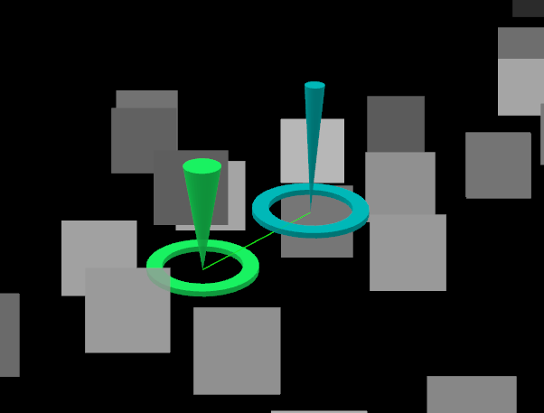

* After Reoptimization, another thing to check for is the **position error** between initial position and computed position. The blue cone is the initial position, the green is the computed position based on the marks. Initially the position error will be large. As **more images are marked**, this error will be reduced. Ideally you want these to be **on top of each other**, or relatively close. Additionally, check that the computed position is **level** with the ATP cloud, and not **floating in the air or underground**.
* Lastly check for the **Theoretical Error**. This indicates the accuracy of the reconstruction of the 3D point. If the error is large, you may need to **mark more images**. Generally, this should be less than 3 times the GSD (ground sampling distance). For example, for a GSD of 12 cm, **the error should be less than 36 cm or 0.36 m**. The GSD can be found in the Quality Report. You can also visualize the theoretical error in the rayCloud editor by enabling the **‘Show Error Ellipsoid’** check box. Also look around in the point cloud and make sure that the **Error Ellipsoids** are **similar sizes**.

<https://support.pix4d.com/hc/en-us/articles/202559139-What-is-the-Theoretical-Error-S-X-Y-Z-of-a-computed-3D-point->

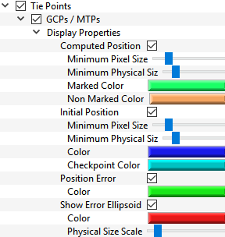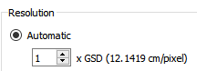

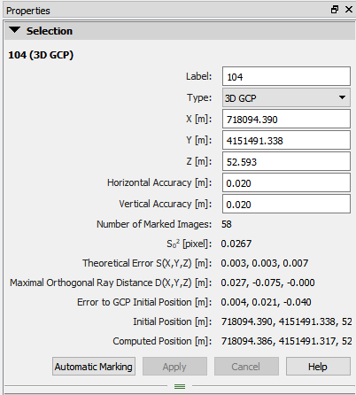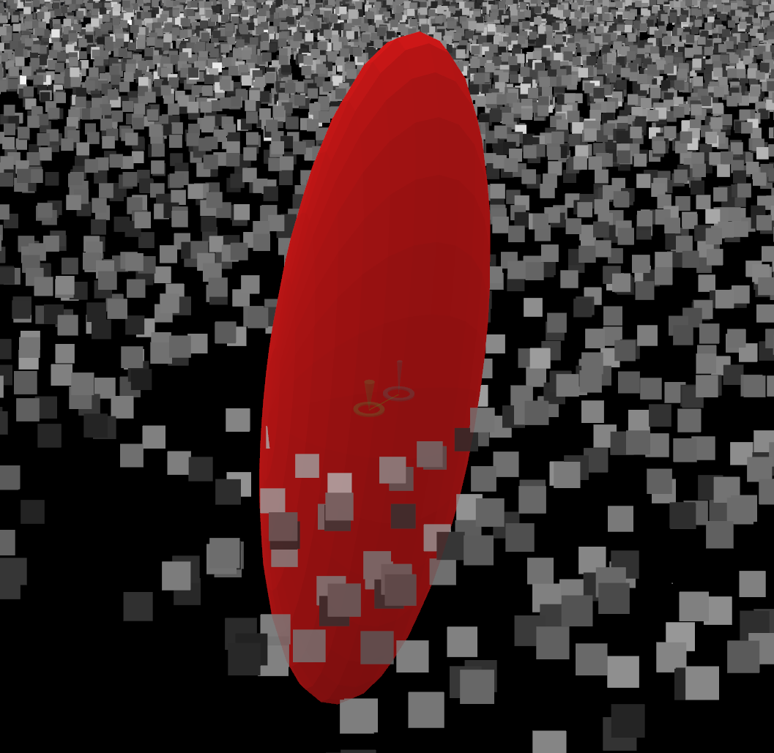

Step 7 – Point Cloud, Mesh, DSM, Ortho, Index Generation

* After GCPs are marked and reoptimized, you can run both step 2 and 3.
  + Check the **2. point cloud and mesh** and **3. DSM, Orthomosaic and Index** boxes and hit **Start**. This will automatically start processing the rest of the outputs.
  + Do not open up any other pix4D projects while this is running, it may cause the program to crash. Do not move the folders while this is running.

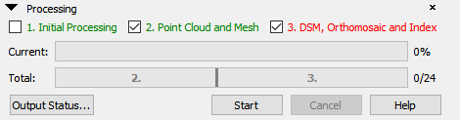

* You can check the progress of the project under the processing tab. You can also check the output status by clicking **‘Output Status’**

Post Processing

* After Processing has finished, check to see if all outputs were created.
  + Click **Output Status**
  + Clicking on an output box will bring up the output description and allow you to go directly to the output folder
  + Check to see if **all desired outputs were generated**
* **Update** the Data Tracking sheet and **move completed project to the C drive**
* Quality Check; open up **Quality Report** in Initial Step Folder of the Results. Check to see everything is **green** and note if the **RMS error** is **less than 2 times the GSD**

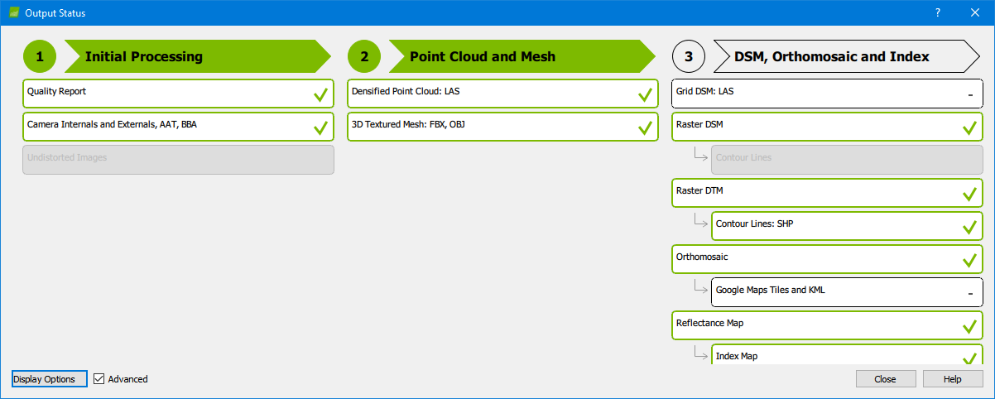

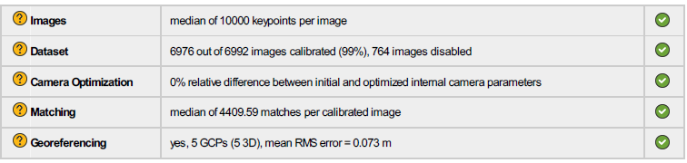

For more information on the Quality report visit:

<https://support.pix4d.com/hc/en-us/articles/202558679-Quality-report-specifications>

<https://support.pix4d.com/hc/en-us/articles/202558689>

* Merged Projects

<https://support.pix4d.com/hc/en-us/articles/202558529>

Step 1 – Process Individual Projects

* Identify which flights need to be merged.
* Flight A and Flight B should have enough overlap to be merged. You can merge more than two projects at a time, but if there is an error, you waste more processing time.

Flight A

Flight B

GCPs/MTPs

* Process **Initial Step** for each flight, following the same procedures as a standard project (**Steps 1 – 4**).
* Do not forget to **Reoptimize!**
* These individual projects are called **subprojects**. You will not be adding GCPs.
* Check for any errors in the sparse point cloud (See Standard Project Step 4).

Step 2 – Add Manual Tie Points

<https://support.pix4d.com/hc/en-us/articles/202560349-How-to-add-import-and-mark-Manual-Tie-Points-in-the-rayCloud>

* Once initial processing step has been done for each subproject, open up the **rayCloud** editor on **both** projects
* Identify the **overlapping** section in each project. This area has **common features** between both projects and should be where **MTP**s are marked
* **Manual Tie Points** are 3D tie points that are created by the user from marking features on multiple images, at least three images need to be marked for a point to be considered as a tie point. At **least** **3** MTPs are recommended per merge, **distributed evenly** as shown above.

* To **choose** a feature to potentially become an MTP, first click on an automatic tie point in the sparse point cloud within the overlapped section. Choose an area where there would likely be identifiable features, such as near a shoreline, or a road. Clicking on a point will bring up its properties and images. **When choosing MTPs, try to pick points that are covered by more than one row of cameras.**

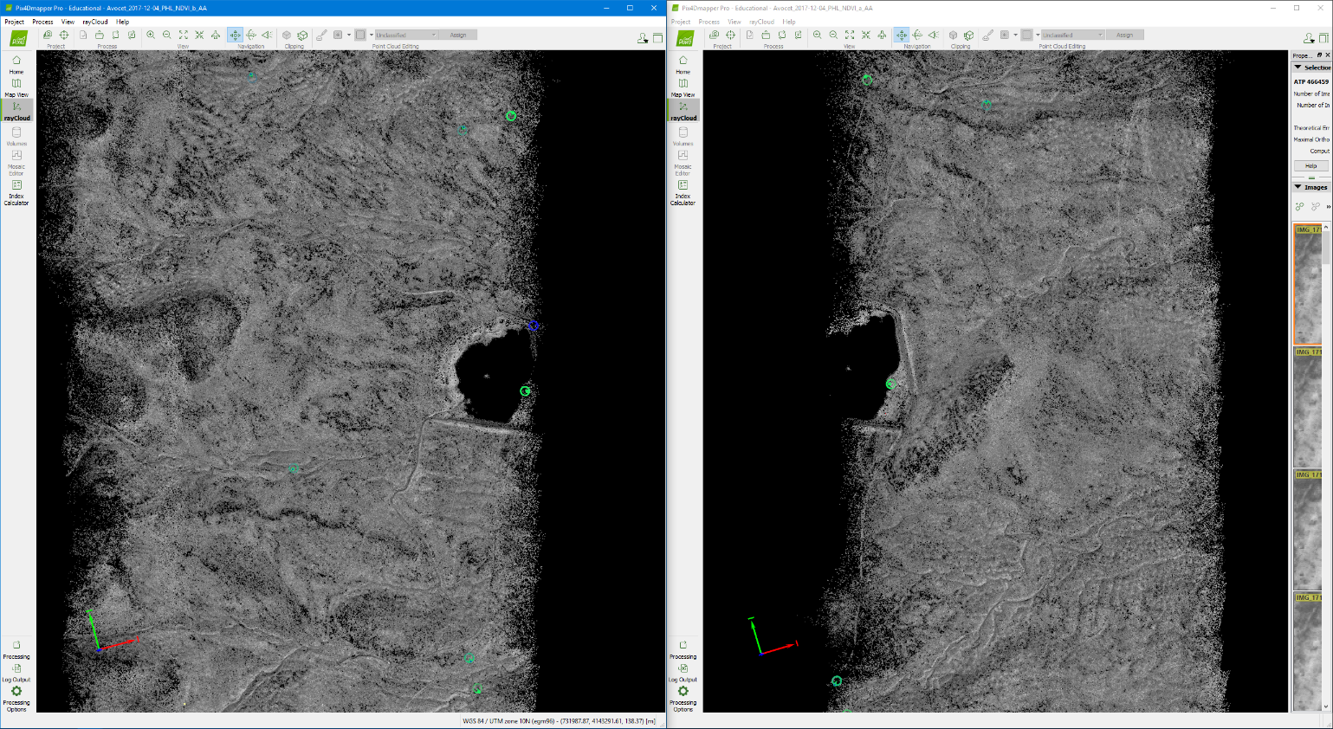

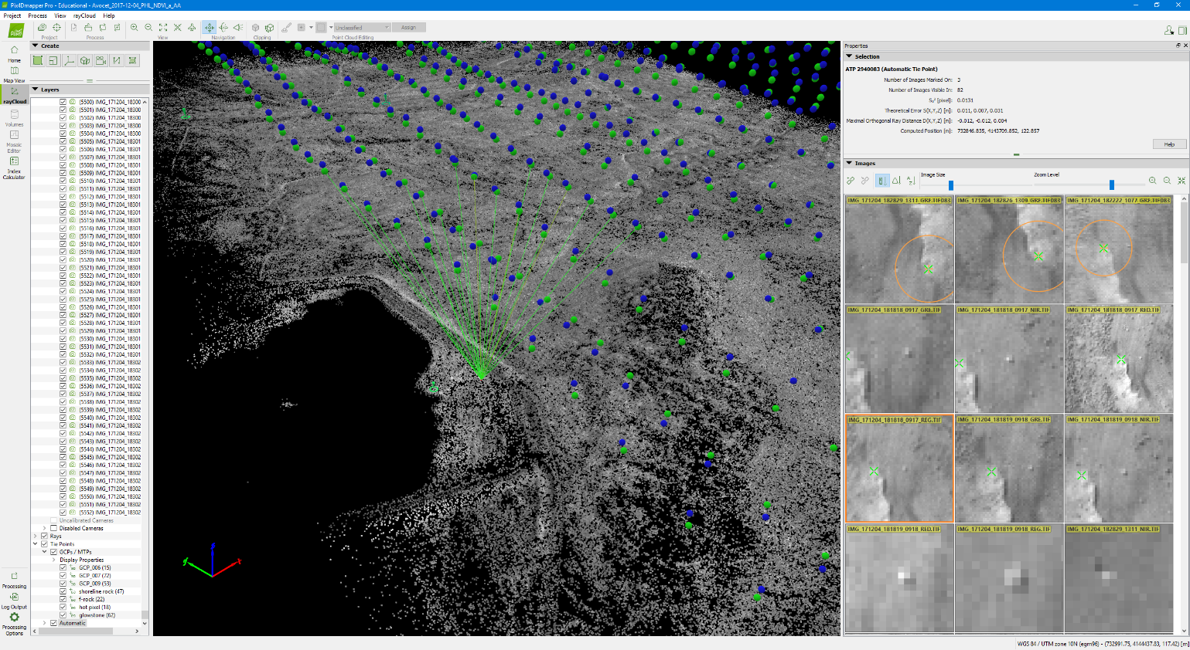

* Expand the image properties bar and explore the images to see if there are identifiable features such as bright rocks. Make sure that this feature can be easily seen on **both subprojects**.
* Below you can see that there is a **rock** that that stands out near a ridge. Something like this can work, especially if you zoom in all the way and a **specific pixel** can be identified. The goal is to be able to have accuracies comparable to marking GCPs, so choose small features that can be pin-pointed to a reasonable degree (**high zoom level**).
* Finding identifiable features is difficult and takes a lot of time, keep in mind that both projects need to have the **same features**. Also keep in mind that some images will be flipped depending on the camera direction and angle. Try not to pick features that are close to the **edge** of images.

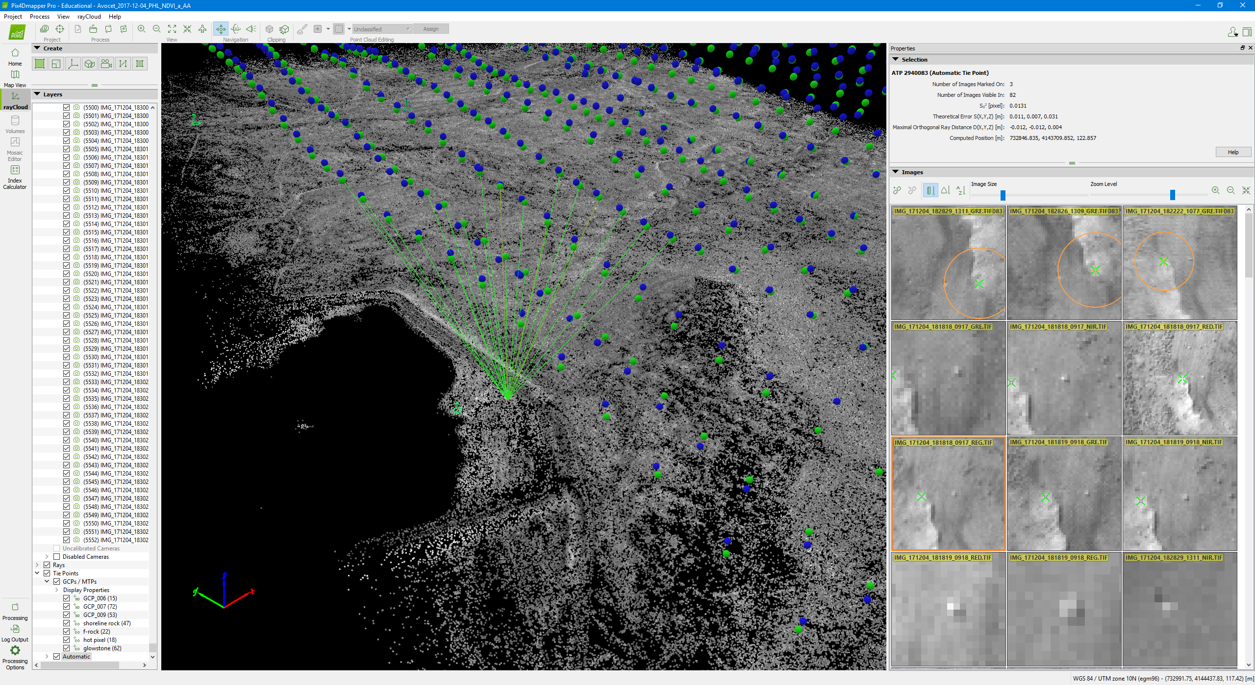



* To **add** an MTP click the **‘New Tie Point’** button on the images sidebar. A new tie point will be created and its properties will appear on the sidebar. This tie point will appear under GCPs/MTPs on the display panel. You can change the name of the tie point under **Label** or right click the tie point and click **Rename**. Both projects need to have the **same** labels for each unique MTP.
* For changes to be saved, the feature needs to be marked on at least **two images**. The procedure is similar to GCPs in that you are marking the same feature on multiple images (See Standard Project Step 5). You may use Automatic Marking once the computed position is close to the actual feature position on the images, but double check the results. Make sure to hit **Apply** and save the project.

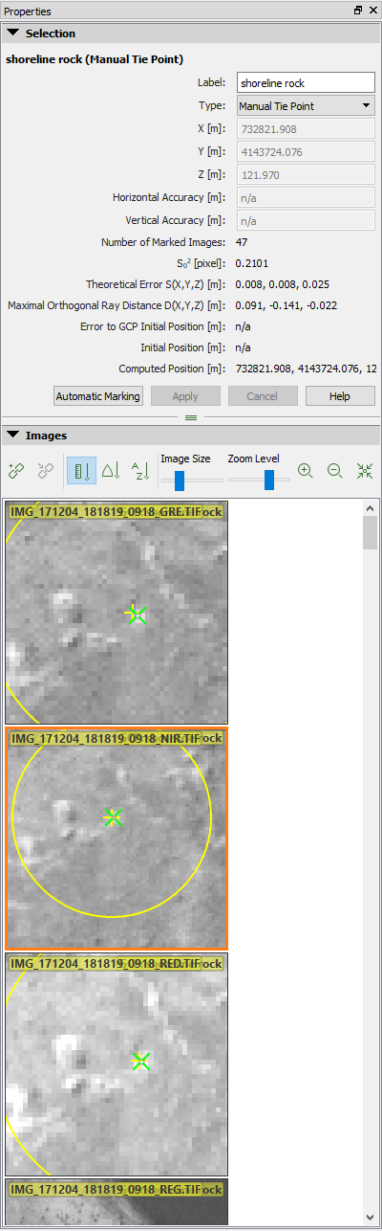

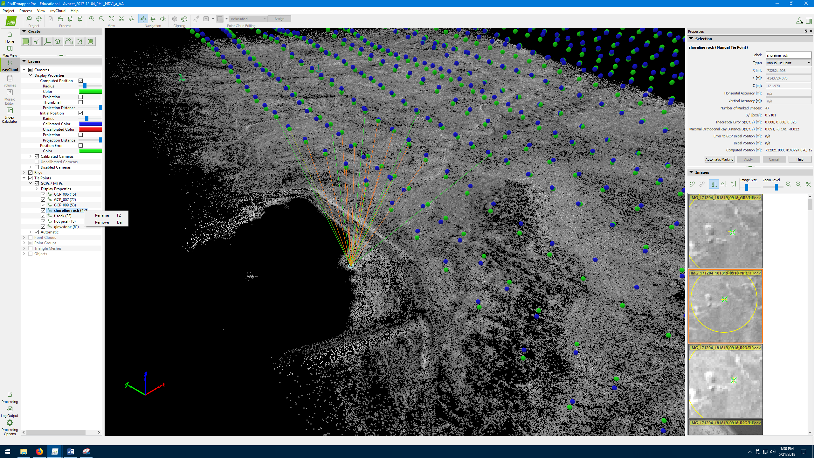

* Remember to check the quality of the marking by zooming in closely and checking to see if the correct pixels were clicked.
* Don’t forget that the program will weigh the marks based on **zoom** levels so pick features that are easily distinguishable when zoomed in.
* Remember that this tie point needs to be marked on **both** **subprojects**.
* **Each** MTP needs to have the **same** name on each subproject.

Step 3 – Reoptimize Subprojects

* Each time MTPs or GCPs are added, the project needs to be **reoptimized**.
* Once finished with MTP markings, reoptimize both subprojects.



Step 4 – Create Merged Project

* A new project needs to be created for merging. Instead of selecting New Project, select **‘Project Merged from Existing Projects’**.
* Additionally, you will include the flights/areas that the merged project originated from in the Project name.
* Click **Next** and select **‘Add Projects’**
* Navigate to the two .p4d projects and add them to be merged.
* **‘Dubplicate Camera Parameters’** is checked by default, and should only be unchecked if using two different cameras for the flights that need to be merged.

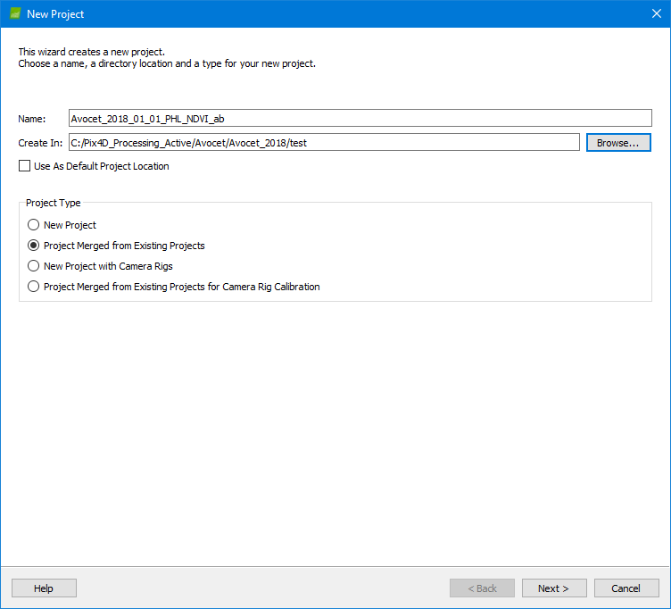

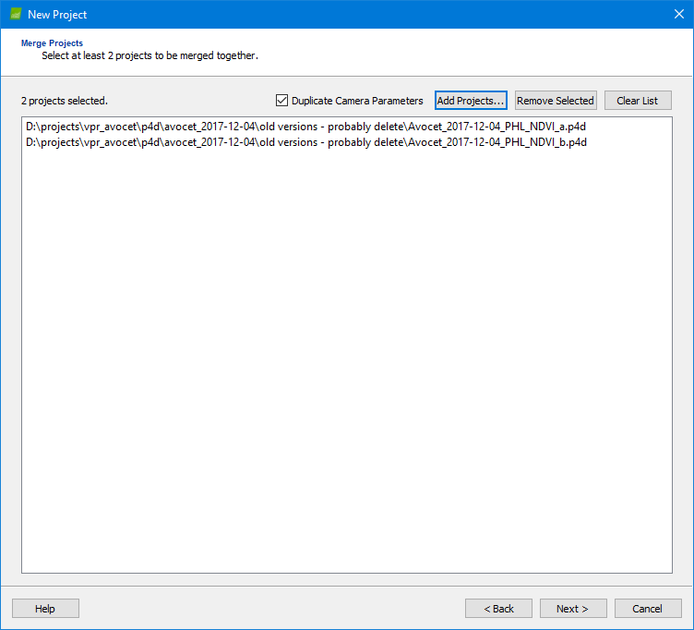

Step 5 – Check Sparse Point Cloud

* Upon creating the merged project, it will automatically start processing.
* The program will merge the two projects and create one point cloud.
* Check to see if more than one **block** is created, if so you may need to add more tie points or rematch and reoptimize (see troubleshooting).
* Just like in the standard project, look around the sparse point cloud and see if there are errors such as layering or gaps.
* Zoom into the MTPs and **check for layering**. Usually if there is layering near the MTPs it means they were marked incorrectly.
* If there are errors in marking, you can **correct them directly** in the merged project. You can do this by selecting the manual tie point in the Layers toolbar on the left.
* You may also **add new tie points** in the merged project.
* If this doesn’t work you may need to mark the individual projects and merge them again.

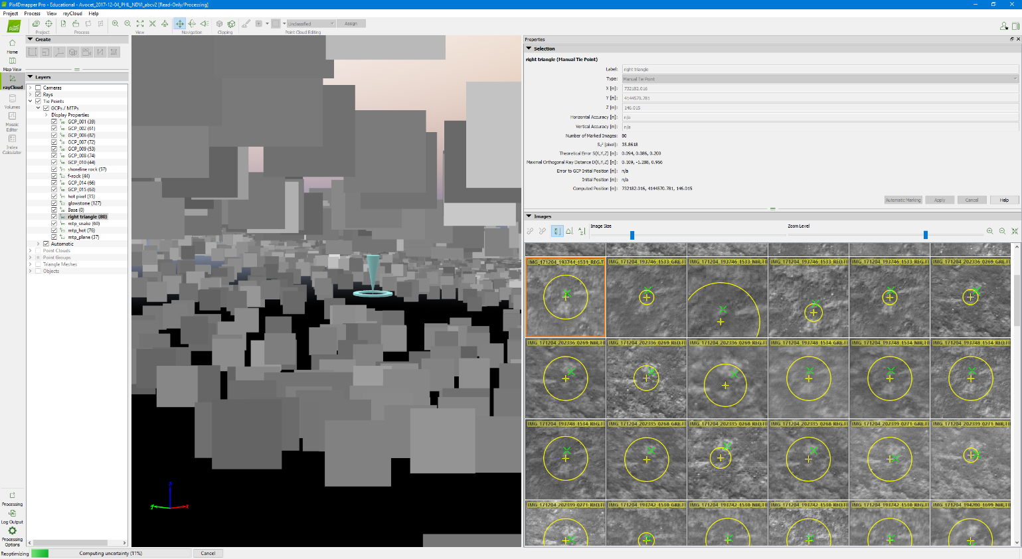

Step 6 – Reoptimize

* Once you check the quality of the sparse point cloud, **reoptimize** the project again.
* If there were any errors in merging, reoptimizing may fix it

Step 7 – Add GCPs

* After reoptimizing, GCPs need to be added.
* Follow the same procedure as the standard project.
* After adding the GCPs, the project needs to be **reoptimized**

Step 8 – Process Steps 2+3

* After GCPs are added, steps 2 and 3 can be processed.
* Follow the same procedure as the standard project.
* Don’t forget to check the quality of the results.
* GoPro Imagery – Georeferencing Images
* If images are taken with the GoPro (**3DR Solo** flight), the images will need to be georeferenced. You will need a laptop because the workstation does not have a wifi card.
* You will need the following programs
  + MissionPlanner (workstation) <http://ardupilot.org/planner/docs/common-install-mission-planner.html>
  + WinSCP (laptop) <https://winscp.net/eng/download.php>
  + Pix4D (workstation)



* **Get Dataflash logs**
  + Turn on the drone and **connect laptop** via wifi (SoloLink_DRONE)
    - Wifi password: solosolo
  + Open up **WinSCP** program
    - File Protocol > SCB
    - Host Name > 10.1.1.10 (Solo) (10.1.1.1 is the Controller)
    - Port > 22
* Username > root
* Password > TjSDBkAu

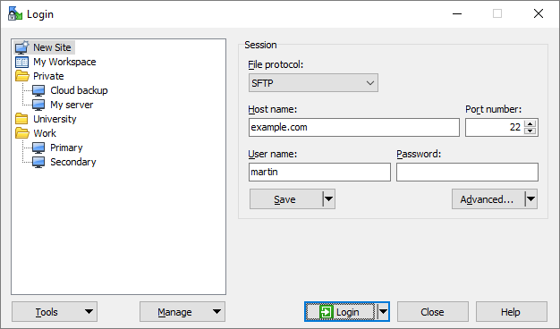

* Left interface is your computer, right is solo’s files
  + Navigate to root>log>dataflash
  + Select files to download [Note: The drone generates a log every time its turned on, and it labels them 1..2..3…etc]
  + You can copy and paste or download to the directory on the left window
  + The changed date indicates useful files, logs should correspond to the date and time flights were done, verify that the number of logs you have is the same number of flights done that day (how many image folders are there a..b..c..d.. etc)

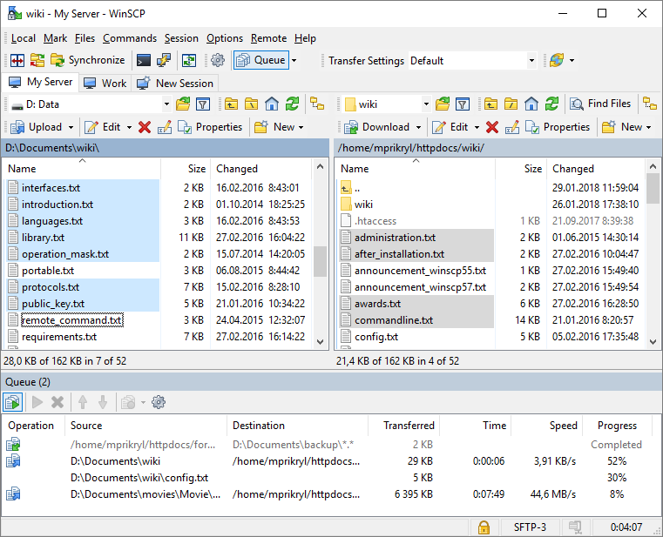

* + The logs should be saved in the data folder **with the images**. Create a new folder labeled **Logs**.
* **Bin to Log**
  + All logs from goPro will be in binary file (.BIN) format, this needs to be converted to a more readable file.
    - Open up **mission planner**, in the main screen under flight data, select the DataFlash Logs tab. Click **PX4 .Bin to .Log** and select all the files you want converted and press enter. New text files of the logs should show up in the folder.

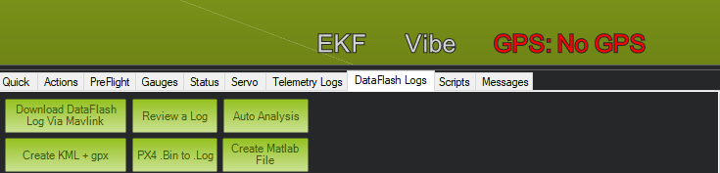

* + - You also want **jpeg maps** of all the logs. You can do this by reading one of the logs, which should automatically generate a thumbnail. If this doesn’t work in mission planner, you can manually map the logs by pressing **ctrl + F** to bring up a menu. Click the option **map logs** and select the **directory** containing all the logs.
* **Geolocation files as .csv**
  + Start a new P4D project, this will be a temporary project that you will only use to get the georeferenced csv files. You will **delete** this project afterwards.

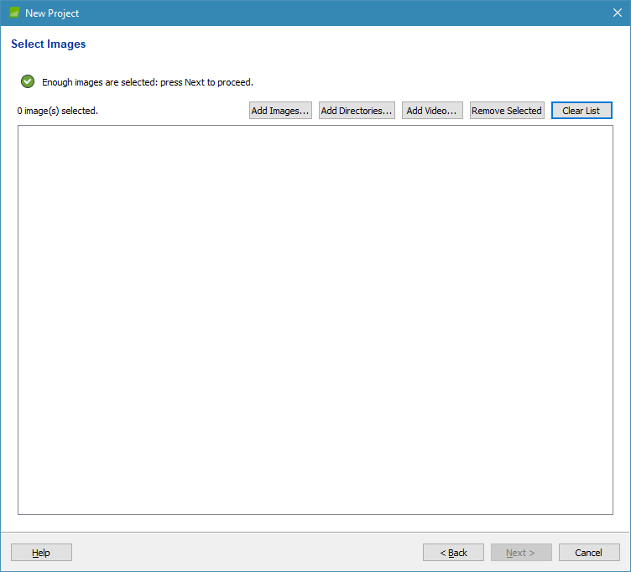

* + First **load the images** you want georeferenced, for example “flight a”. You will export csv files **one at a time** for each flight. Do not load more than one flight at a time.
  + Then determine which log corresponds with the set of images. You can use the map jpegs to see where the start of the flight is. The logs are in number order, so you can use the logs in order.
  + **Note : If you have only one flight to process and know which log it corresponds to, you do not have to export the log as a csv. You may use the .log file directly as a “3D Robotics Flight Log” format (See next page).**

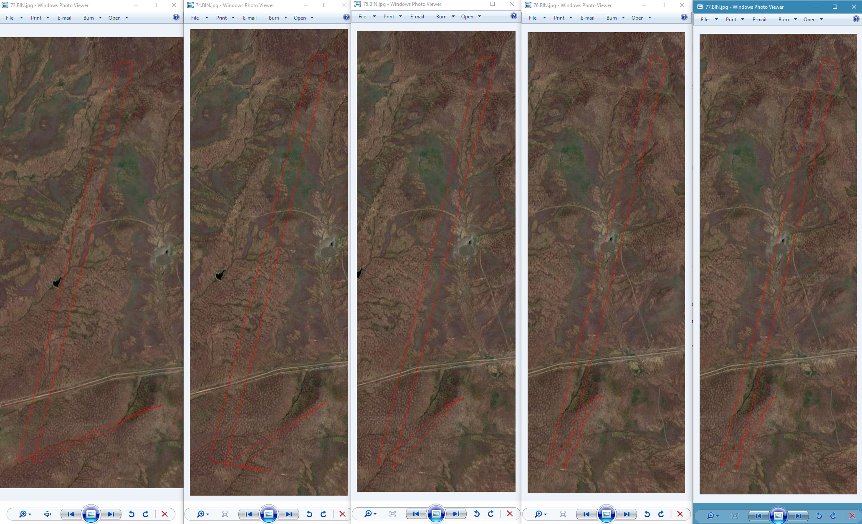

* + For example, I know that the first map on the left is the first transect. This is the jpeg image for log “84”, so I know log 84 is when the flight started. This would mean that the first flight “flight a” corresponds with log “84”. All following logs will be in order, “85” is the second flight, “flight b” and so on. Be careful though, and always make sure that you have the same amount of logs as the flights. There will be cases, such as the two images on the right, where a transect is redone. You can see from the log image that the red transect goes over the same spot twice. In this case we usually use the newer log e.g. “87” instead of “86”.
  + It is better to match the logs with the flights before trying to convert them to csv in pix4D. A matching scheme will go something like this.
    - Flight a: log “84”
    - Flight b: log “85”
    - Flight c: log “86”
    - Flight d: log “87”
    - And so on…
  + Document this somewhere in case it needs to be corrected

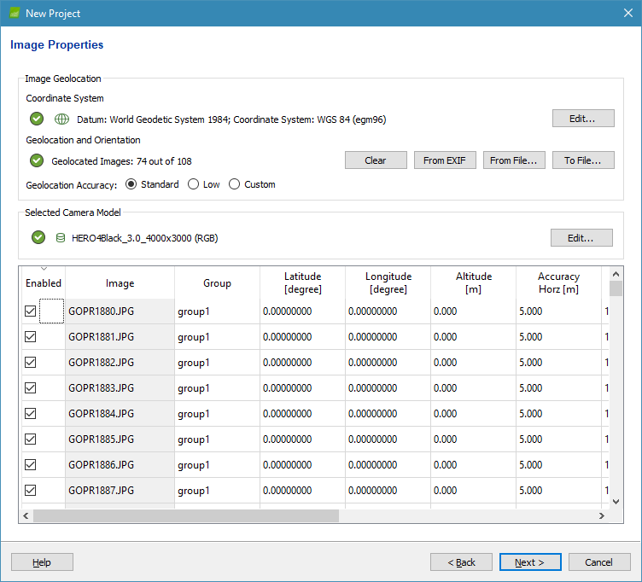

* After loading the images, hit **next**. Coordinates for the images will be 0’s.
* Under **Geolocation and Orientation**, click **From File**…

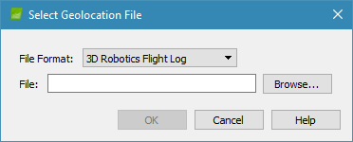

* Select **the log that corresponds to that flight**. The file format is **3D Robotics Flight Log** when using the **dataflash logs**. Select brose and look for the corresponding log For example Flight a: log “84” you would select “84.log”
* Locations should now be occupied
* Check to make sure there are no significant amount of 0’s in these fields by scrolling down
* If an error message pops us it is probably the **wrong log**

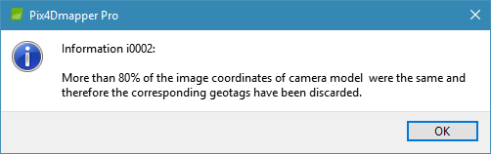

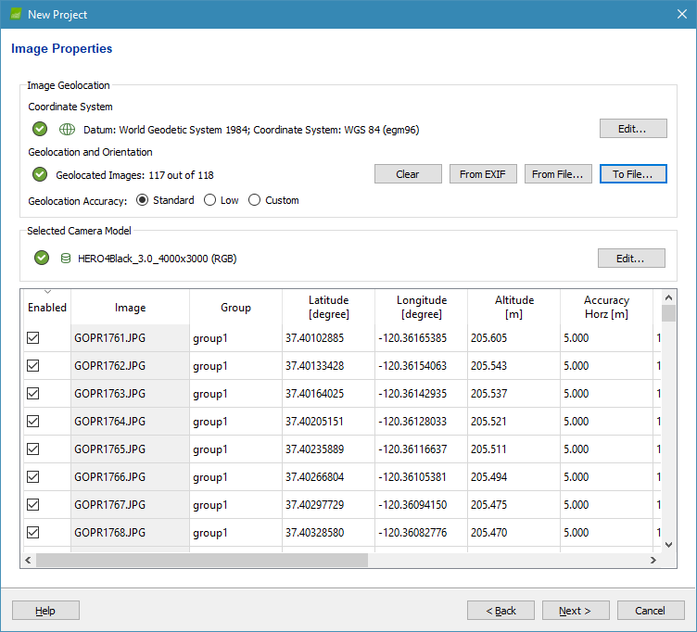

* Once geolocation has been loaded, export the file to csv by clicking **‘To File…’**

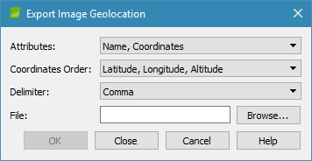

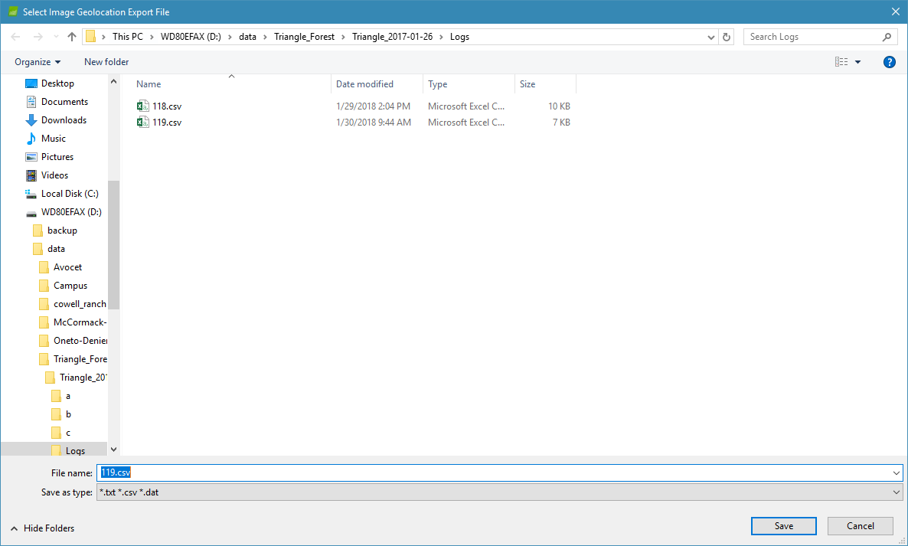

* You will export the csv in **Lat, Long, Alt**, format. Name the file with the corresponding flight. For example, flight a should be named “a.csv”. Put the csv file in the logs folder of the flight images. Hit save, then OK
* Once you hit OK, **do not click next**. Instead, go back and select **clear list** to load in another flight. Then repeat the previous steps to get another csv file for that flight. You should have as many csv files as there are flights.
* Once all the flights have a corresponding csv log file, you must **consolidate** all the csv files into one file containing the georeferenced of all the flights. You will name this “all.csv” This will be the file that you will use to georeference the project.
* In Microsoft excel, start a new sheet and copy and paste all the georeferenced information from all the flights in that sheet. Make sure it is in order, “flight a, b, c, d”.
* Each flight log will likely have the last image as 0,0,0. From experience it is better to have the first image be 0,0,0 instead. When consolidating the logs, shift the coordinates down so the first image of each flight is 0,0,0.
* An example can be found on the workstation

D:\data\Avocet\Avocet_2017-11-15\Logs

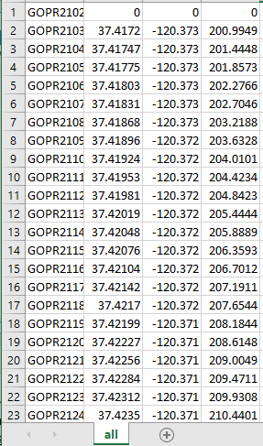

* Load Georeference to Project
  + Load the flights you want to process.
  + In the image properties window, select “From File”



* + The file format depends on what you exported the geolocation file as, in our case we exported as Lat, Long, Alt. Select the drop down menu and click Lat, Long, Alt format. Browse to the csv file “all.csv” and hit OK.
  + **Note : If you have only one flight to process and know which log it corresponds to, you do not have to export the log as a csv. You may use the .log file directly as a “3D Robotics Flight Log” format.**
  + Double-check to see there are not too many 0’s in the geolocation fields.
* Troubleshooting

Most errors occur after initial step has been processed and the sparse point cloud is generated. Most of them can be fixed in the rayCloud editor, but some of them will require initial step to be redone. It is important to be familiarized with the different types of errors and know which solutions to pursue, but there are also online resources that may be valuable.

If you are running into an unknown error, search online or look it up on the support page. Additionally, you can post about your problem in the forums or contact support directly.

<https://support.pix4d.com/hc/en-us/community/topics/200266979-Processing>

Common Errors

**“Layering”**

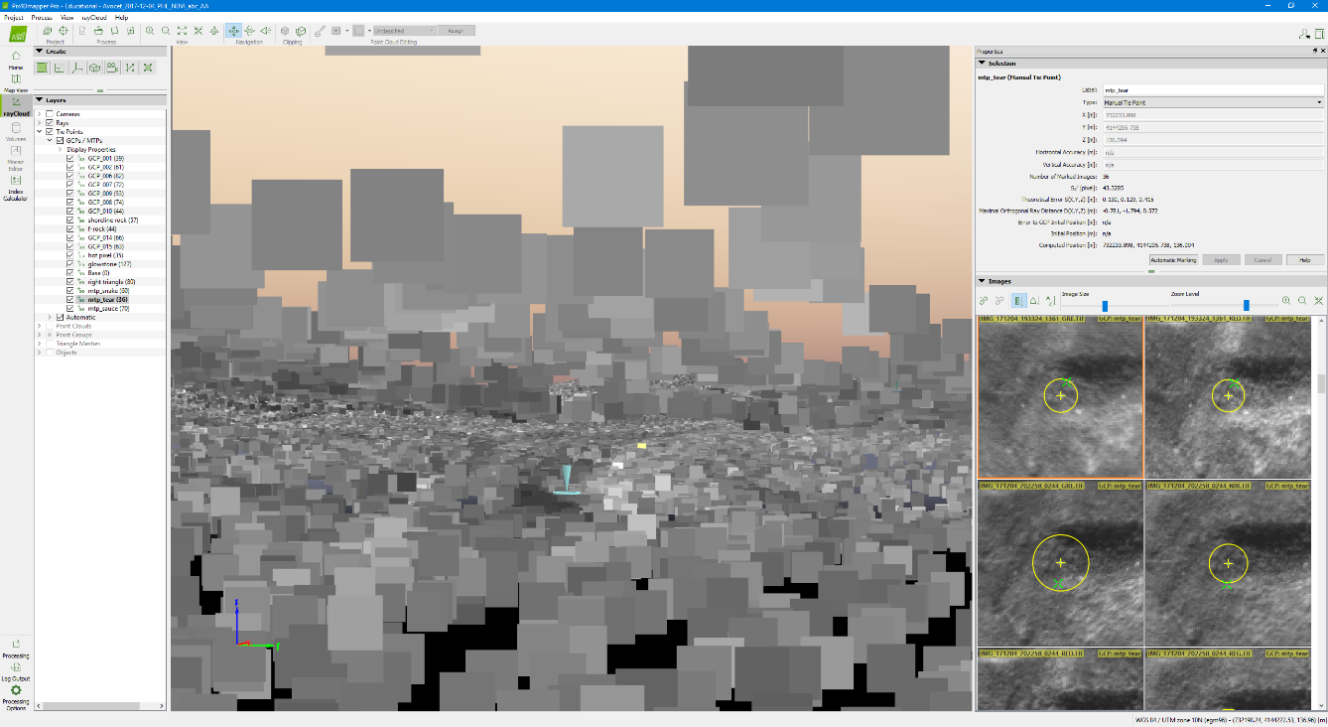

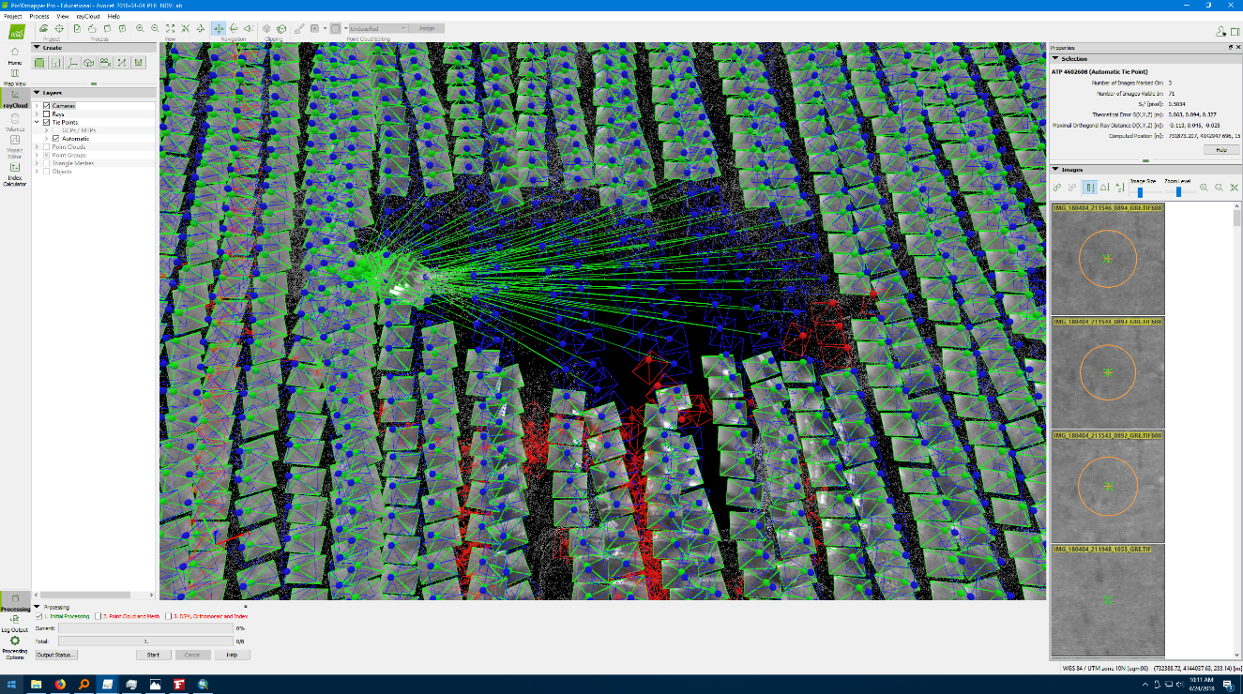**“Gaps/Holes”**

**“Chip”**

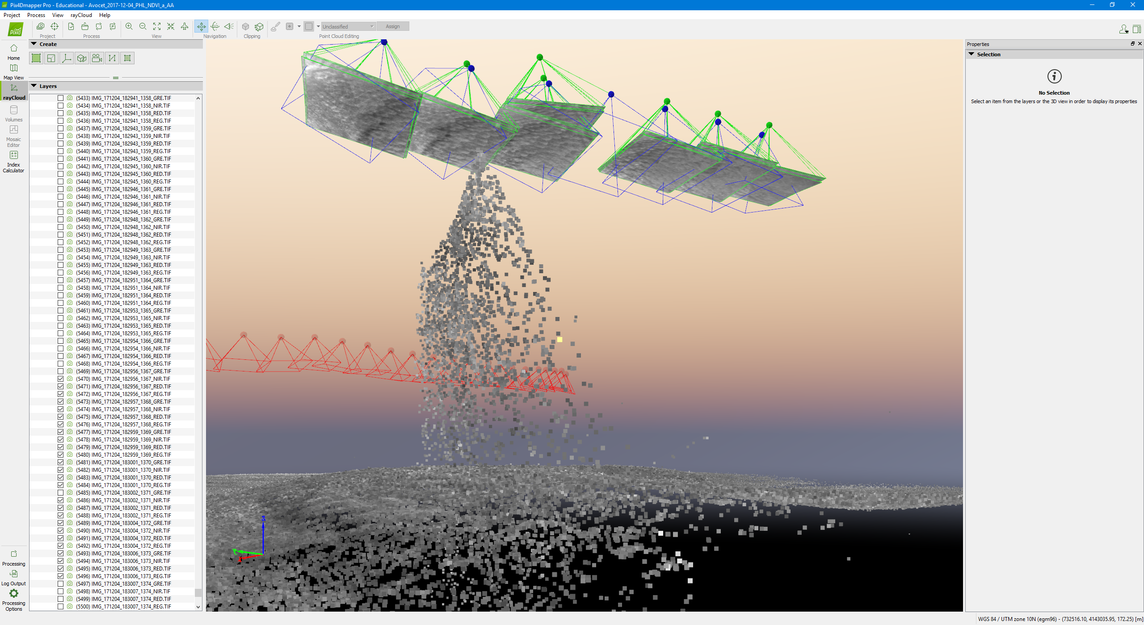

**“Tear”**

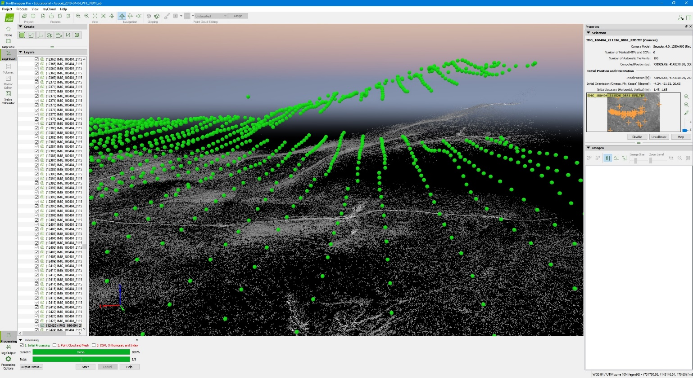

**Floating or Underground GCPs/MTPs**

If there is an error with a GCP, it is usually because it was marked incorrectly. It could also mean that the coordinates are off. Ensure that the loaded GCPs are in Y, X, Z format and that the coordinates are the correct RTK locations.

**Failed to Process**

Projects will sometimes not complete initial processing due to insufficient matching or errors in image calibration. This is indicative of the wrong processing options selected, or problems with the dataset itself.

**Missing Outputs**

If there are some outputs that were not generated, you can generate them directly by selecting them in the processing tab. Check to see if the processing template you used included the necessary outputs.

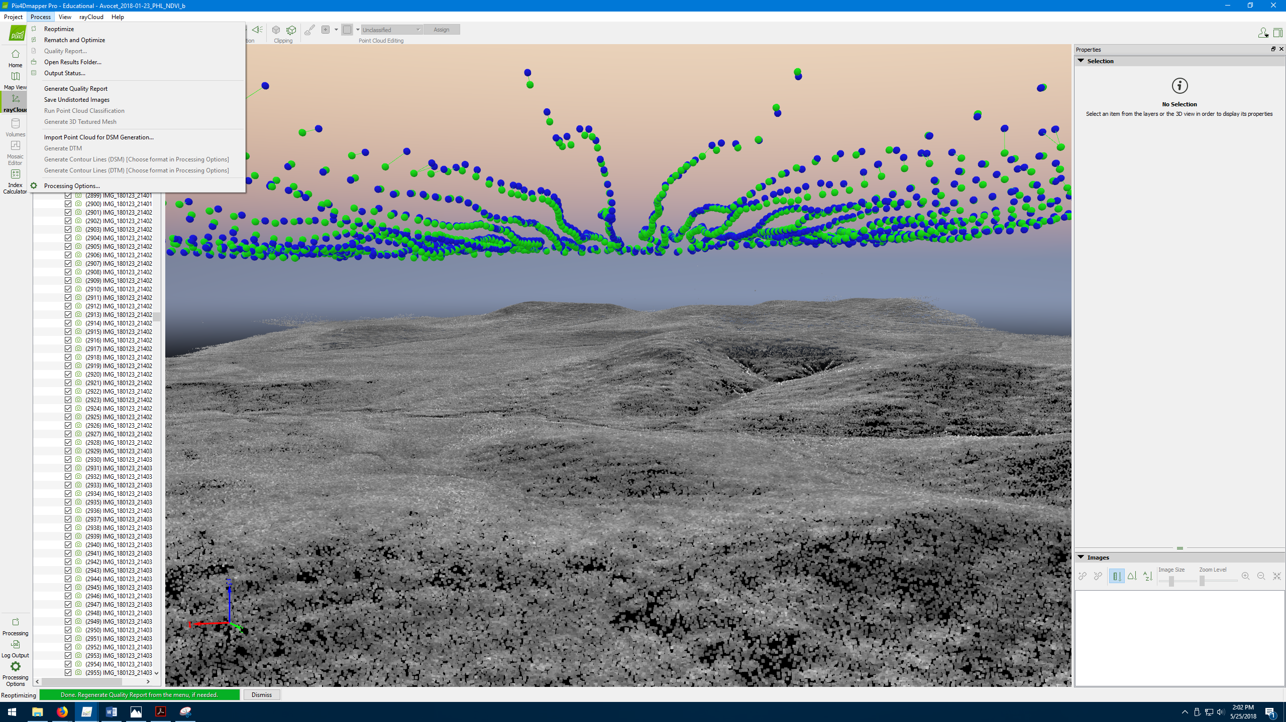

Solutions

**Quality Report & Processing Log**

<https://support.pix4d.com/hc/en-us/articles/202558689-Quality-Report-Help>

If errors occur, the first thing to check is the quality report.



Furthermore, Pix4D generates a log of the project. The log is useful for seeing any errors and in what step the error was for. You can access the log in the output folder of the project. Alternatively you can see the log on the bottom of an opened project.

**Reoptimize**

Reoptimizing is sometimes all it takes to fix layering or other point cloud errors. If camera issues are not detected and the error is relatively small try reoptimizing.

**Rematch & Reoptimize**

In cases were there are not enough matches and there are a lot of uncalibrated cameras, it may be good to rematch and optimize. This will compute new matches and may fix errors with merging.

<https://support.pix4d.com/hc/en-us/articles/202559359-Difference-between-Reoptimize-and-Rematch-and-Optimize->

**Disable Cameras**

Check the cameras to see if there are large position errors between the computed position and the initial position. You can see this better if you disable the projections and the image thumbnails. The green dots represent computed positions and the blue dots indicate the initial positions.

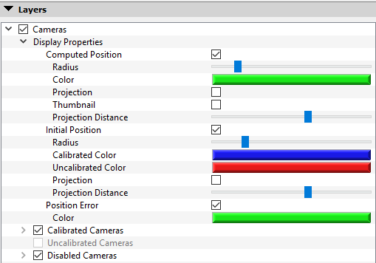

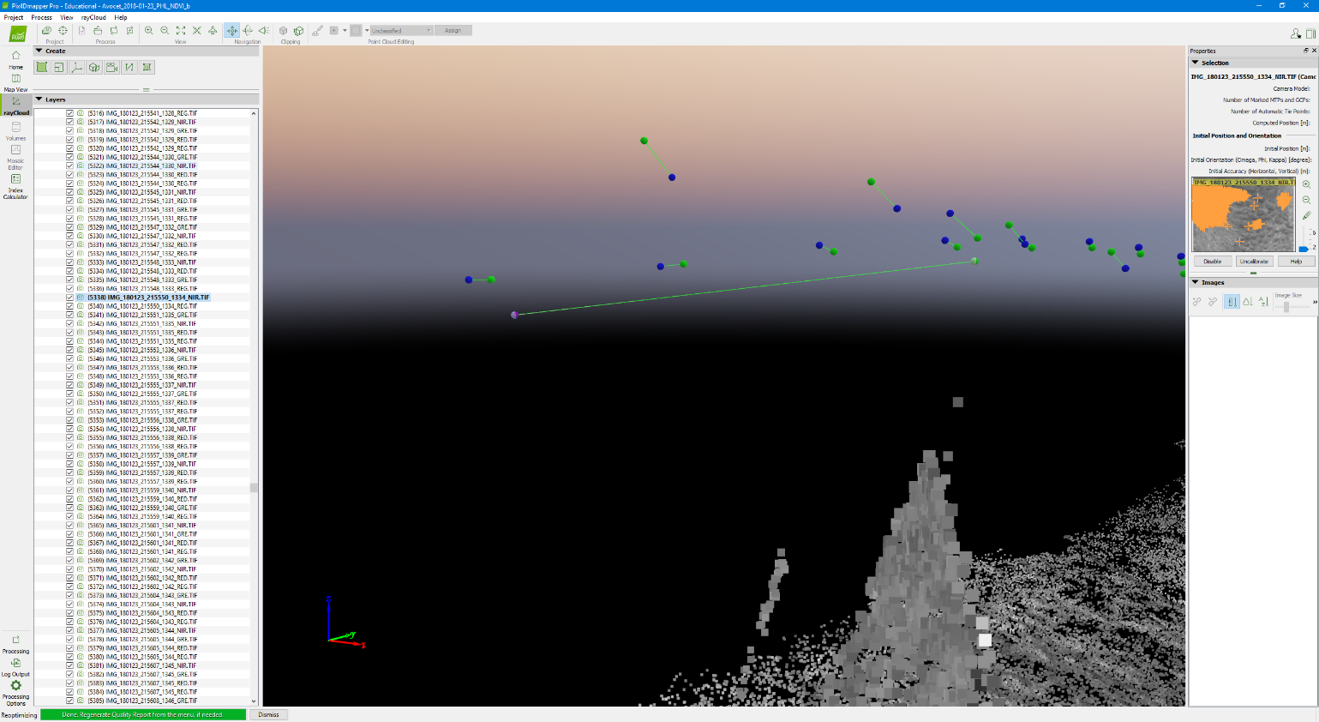

Artifact!

Large position error!

Few matches!

* Clicking on an Image (green dot) will bring it up in the display panel on the left. It will be highlighted.
* To disable the problematic camera click **‘Disable’** on the properties editor. **You will have to disable all the images for all the bands**. Alternatively, uncheck the box on the display panel for the images you want to disable.
* After you have disabled the desired camera, reoptimize the project and see if the error has disappeared.

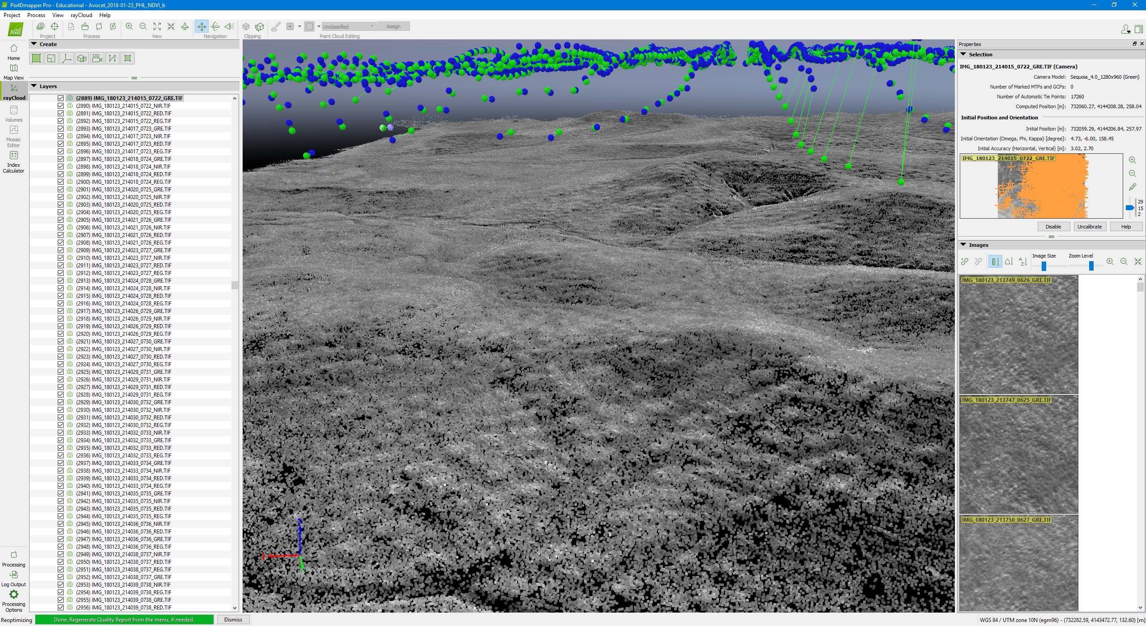



**Different Processing Options**

<https://support.pix4d.com/hc/en-us/articles/202557759>

* In some cases, a different **processing option** will fix the error.
* Changing the Matching Options and Calibration Options will require some research.
* Generally, some errors can be fixed by enabling the **Geometrically Verified Matching**.

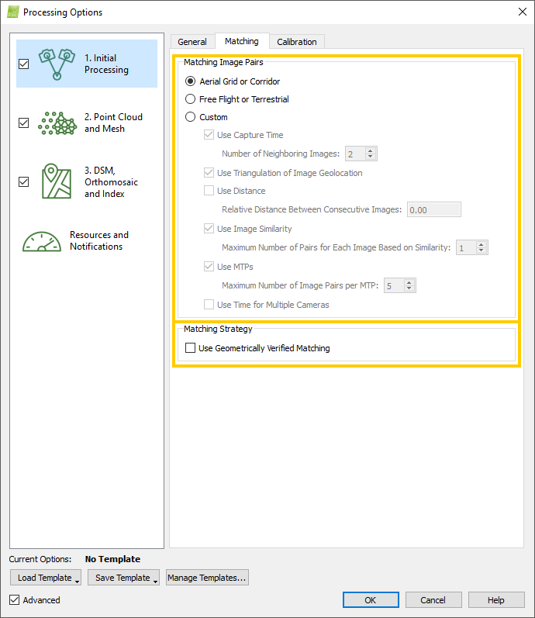

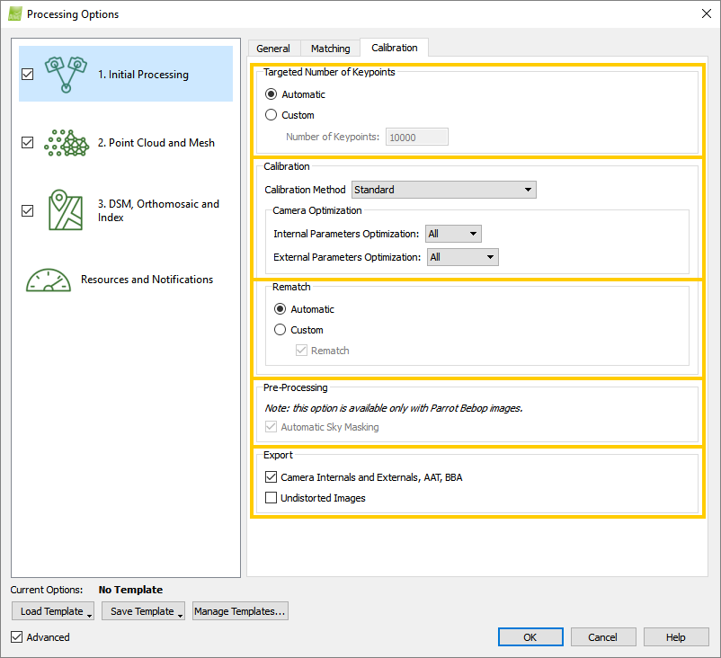

**Check Camera Model**

If the program is having trouble calibrating the cameras, check to see if the correct camera model is inputted. If you are using a camera that does not have a default profile, you will have to create a new profile enter the parameters manually. You can do this through the image properties editor before initial step is processed.

<https://support.pix4d.com/hc/en-us/articles/202560169-How-to-use-the-Editing-Camera-Model-Options>

For a project with initial step already processed, check to see if the camera positions have high relative errors. If so, you can try loading the optimized parameters and process initial step again. Do not save the created profile (See the article below)

<https://support.pix4d.com/hc/en-us/articles/202560059-How-to-change-the-Camera-Initial-Values-to-the-Optimized-Values>

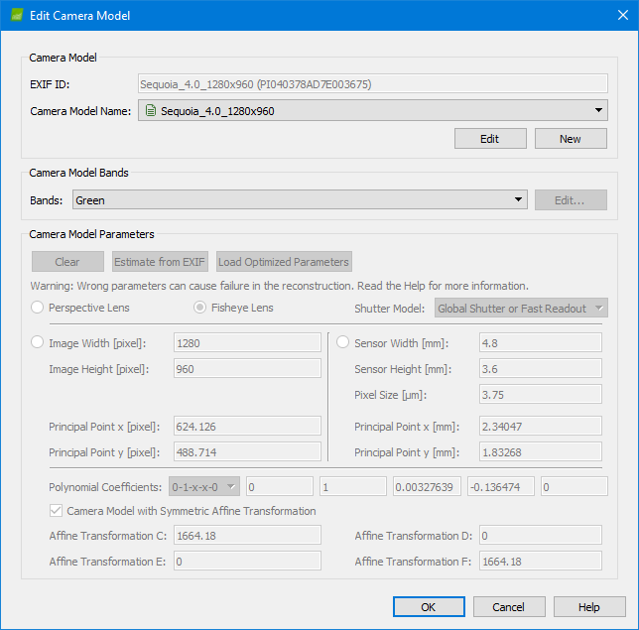

**Adding MTPs/Remark GCPs**

* Merged projects often have errors near MTPs, such as layering.
* Sometimes new MTPs may need to be added. The location of the MTP matters, and you should ensure that they are homogenously placed along the overlapping sections. When adding MTPs, use a zipper-like pattern spaced out evenly.
* Incorrect marking can lead to errors in the point cloud near the MTPs, the same is true for GCPs.
* Remark MTPs and GCPs as needed. First try it in the merged project, and reoptimize. If this doesn’t work you may need to change the MTPs in the subprojects.